EXPERIMENT: 1

AIM: To study the different types of Network cables and network topologies.
APPARATUS:
Desktop, Laptop
APPARATUS:
Desktop, Laptop
APPARATUS:
Desktop, Laptop
Apparatus: Desktop, Laptop
Procedure: Following should be done to understand this practical
NETWORK CABLE
A cable is a device which contains a number of signal conductors usually in the form of separate wires. It is the medium through which information usually moves from one system to another through the network. There are several types of cable which are commonly used with the local area network.
TYPES OF NETWORK CABLE
Twisted Pair: Twisted pair cable is the most common type of network medium used in LANs. A transmission media consists of color coded pairs of two shielded or unshielded insulated copper wires which are arranged in a spiral pattern. The spiral pattern is an important aspect of twisted-pair cables in order to minimize crosstalk or interference between adjoining wires.
There are two varieties of twisted pair cabling, they are:
- Unshielded Twisted Pair (UTP)
- Shielded Twisted Pair (STP)
Unshielded Twisted Pair (UTP): Unshielded twisted pair (UTP) cabling consists of two unshielded wires twisted around each other that contain no shielding. It is commonly used in the telephone wires and is common for computer networking because of high flexibility of the cables. It is a plastic connector that looks like a large telephone-style connector. The standard connector for unshielded twisted pair cabling is RJ-45 connector
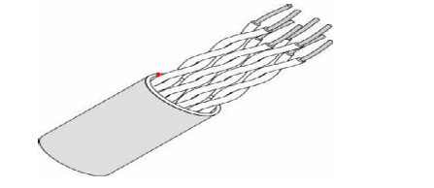
Figure 1- Unshielded twisted pair
Shielded Twisted Pair (STP): Shielded Twisted-Pair cabling is usually used in several network types. STP cable usually contains four pairs of twisted copper wires. It is different from UTP in that the twisted pairs are in a shield with electrically grounded woven copper mesh separating them from the cable’s outer sheath. The essence of the shielding is to provide resistance to external Electromagnetic Interference (EMI) and to prevent crosstalk
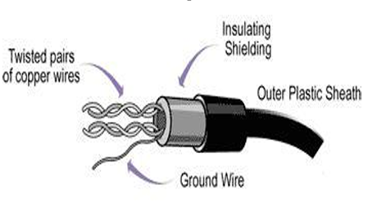
Figure 2- Shielded twisted pair
Fiber Optic Cable: Fiber optic cable is the standard cable for connecting networks between buildings due to its resistance to the effect of moisture and lightening. This technology is popular for LAN but it is expensive and fragile too. The fiber optic cable is designed to carry laser light to a long distance at a high speed rather than transmitting electronic signals. It carries the digital data signals in the form of modulated pulses of light. This is relatively safe way to send the data because electrical impulses are not carried over the fiber optic cable
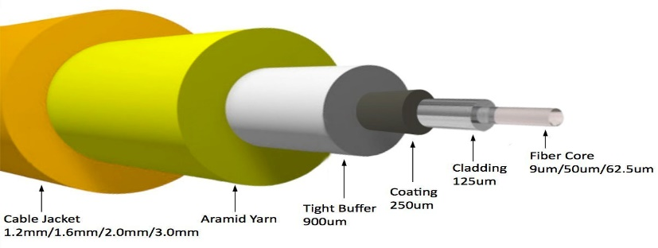
Figure 3- Fiber optic cable

Coaxial Cable: Coaxial cables feature a central copper conductor surrounded by layers of insulation, a woven metal shield, and an outer insulating layer. This construction allows coaxial cables to carry high-frequency signals with minimal signal loss, making them ideal for transmitting television signals, broadband internet, and certain Ethernet connections. Coaxial cables are commonly used in cable television (CATV) networks and broadband internet connections. Compared to twisted pair cables, they can support higher bandwidths over longer distances, making them suitable for applications where reliable transmission of high-frequency signals is necessary.
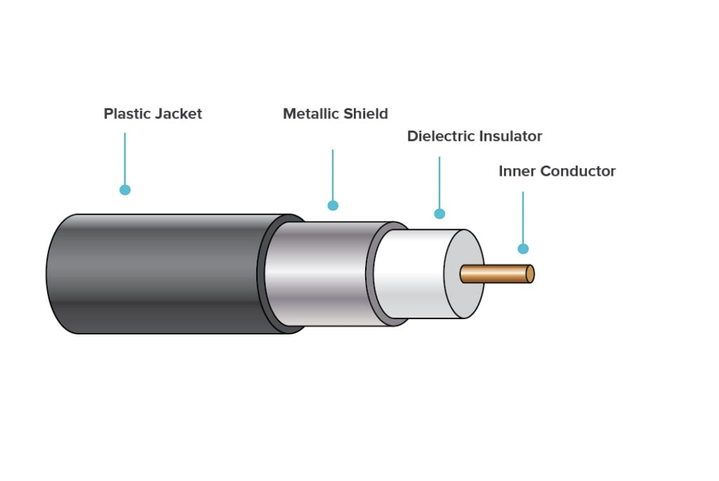
Figure 4- Coaxial cable
Straight-through Cable: Straight-through cable is a cable which has similar wiring at both the ends. It is a standard network cables that connects a computer to a network device like network hub, network switch, and network routers. A straight-through cable has each internal twisted pair of wires connected to the same pin number at each end. The twisted-pair wires must be twisted throughout the entire length of the cable. If the colors in both ends are in the same order, it is a straight-through cable.
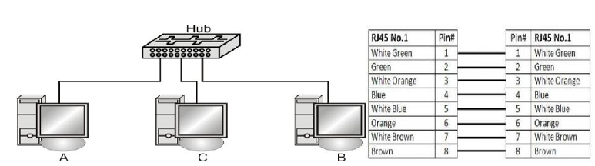
Figure 5- Straight-through cable
Cross over cable: It is also a Cat 5 networking cable, which is generally used to connect two computers or network devices directly to one another without using a network hub, network, router or network switch.
The crossover cable can be used to connect
- Switch to switch
- Hub to hub
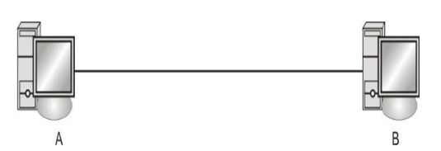
Figure 6- Cross over cable

NETWORK TOPOLOGY
Network topology refers to the arrangement of different elements like nodes, links, and devices in a computer network. It defines how these components are connected and interact with each other. Understanding various types of network topologies helps in designing efficient and robust networks. Common types include bus, star, ring, mesh, and tree topologies.
TYPES OF NETWORK TOPOLOGY
Point-to-point: This basic network topology has only two devices connected. Among the different types of topology, it is the fastest.

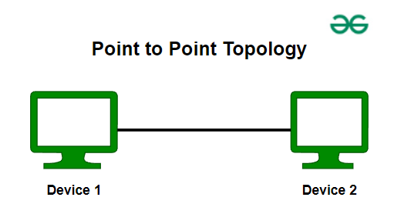
Figure 7- Peer-to- Peer
Star topology: Here, the network devices connect to a central hub. Data first flows to the network hub before reaching the destination.
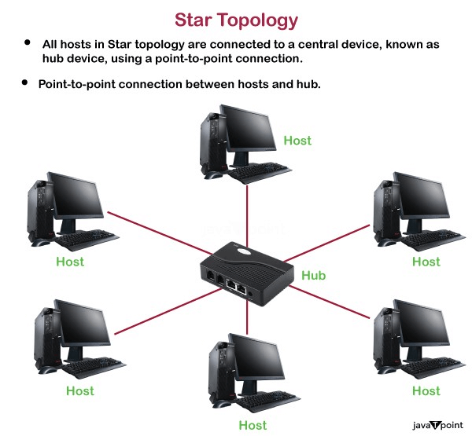
Figure 8-Star Topology
Ring topology: In this topology, each device connects to two other devices. So data needs to pass through the intermediate nodes to reach the destination.
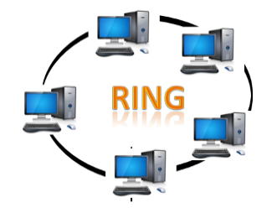
Figure 9-Ring Topology
Bus topology: A bus topology orients all the devices on a network along a single cable running in a single direction from one end of the network to the other—which is why it’s sometimes called a “line topology” or “backbone topology.” Data flow on the network also follows the route of the cable, moving in one direction.
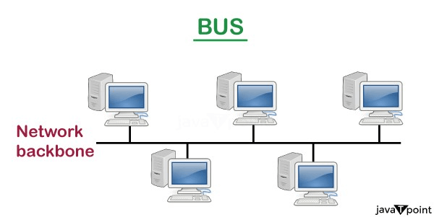
Figure 10-Bus Topology
Mesh topology: A mesh topology is an intricate and elaborate structure of point-to-point connections where the nodes are interconnected. Mesh networks can be full or partial mesh. Partial mesh topologies are mostly interconnected, with a few nodes with only two or three connections, while full-mesh topologies are fully interconnected.

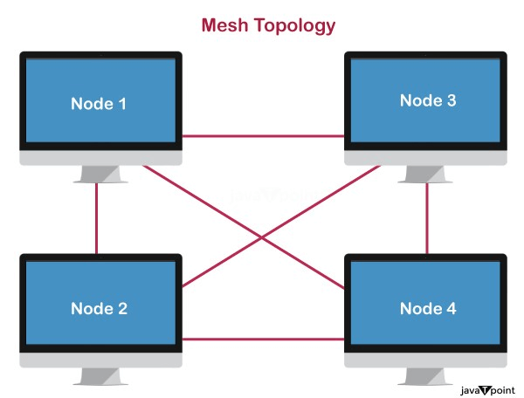
Figure 11-Mesh Topology
Tree topology: Tree topology combines the characteristics of bus topology and star topology. A tree topology is a type of structure in which all the computers are connected with each other in hierarchical fashion. The top-most node in tree topology is known as a root node, and all other nodes are the descendants of the root node. There is only one path exists between two nodes for the data transmission. Thus, it forms a parent-child hierarchy.
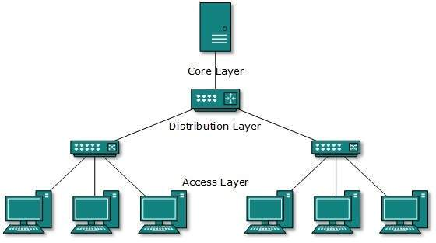
Figure 12-Tree topology

Hybrid topology: Hybrid topology is the combination of two or more types of topology, they arise from the integration of multiple network topologies that is why called Hybrid Network Topology.
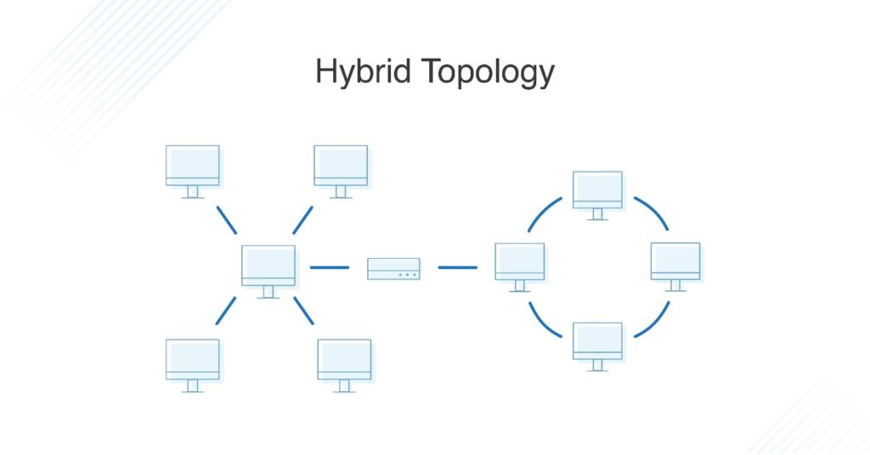
Figure 13- Hybrid topology

EXPERIMENT:2
AIM: Study and familiarization with various network devices.
Hardware Required: Computer systems, 1 HUB, 1 Switch & Router.
Experiment: Familiarization with Networking Components and devices: LAN Adapters, Hubs,
Switches, and Routers etc.
AIM: Study of networking components.
Hardware Required: Computer systems, LAN CARD, LAN Adapters, 1 HUB, 1 Switch, & Router,
CAT-5 Cable ETC
Procedure: Following should be done to understand this practical.
NETWORK DEVICES
Network devices or networking hardware are the physical devices that are used for establishing connections and facilating interaction between different devices in a computer network. Network devices are building blocks that permit communication between services and the endpoints that consume those services.In other words, they're connectors that allow devices on a network to communicate with one another. Enabling communication on a network means anything that helps data get from source to destination.When a network contains a large number of devices, too many data packets are transmitted over the same network path. This can cause congestion and performance reduction. The goal of networking devices is to provide for smooth communication between various hardware linked to a network. Adding a network device facilitates the seamless sharing of network resources between different systems.
TYPES OF NETWORK DEVICES
Repeater: Functioning at Physical Layer. A repeater is an electronic device that receives a signal and retransmits it at a higher level and/or higher power, or onto the other side of an obstruction, so that the signal can cover longer distances. Repeater have two ports, so cannot be use to connect for more than two devices.
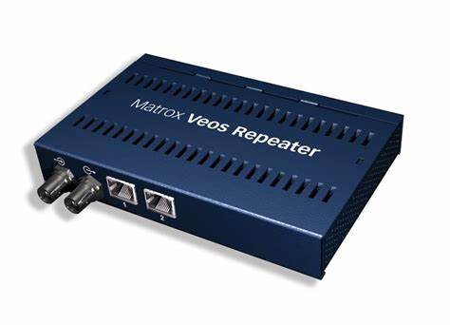
Figure 14-Repeater
Hub: A hub is a basically multi-port repeater. A hub connects multiple wires coming from different branches, for example, the connector in star topology which connects different stations. Hubs cannot filter data, so data packets are sent to all connected devices. In other words, the collision domain of all hosts connected through Hub remains one. Also, they do not have the intelligence to find out the best path for data packets which leads to inefficiencies and wastage.

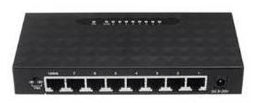
Figure 15-Hub
Bridge: A bridge operates at the data link layer. A bridge is a repeater, with add on the functionality of filtering content by reading the MAC addresses of the source and destination. It is also used for interconnecting two LANs working on the same protocol. It has a single input and single output port, thus making it a 2 port device.
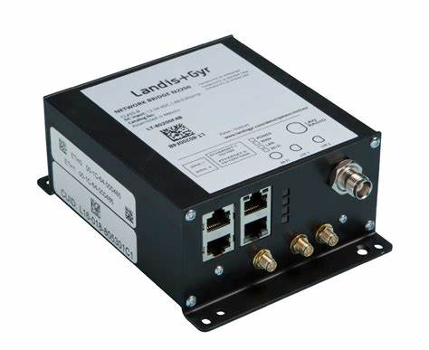
Figure 16-Bridge
Switch: A switch is a multiport network device with a buffer and design that can improve its efficiency (having a large number of ports means less traffic) and performance. A switch is a networking device that operates at the data link layer. A switch has numerous ports into which computers can be plugged. When a data frame arrives at any network switch port, it evaluates the destination address (destination MAC address ) , performs the necessary checks, and sends the frame to the associated device. The switch performs error checking before forwarding the data, making it very efficient because it does not forward packets with errors and only forwards good packets to the correct port.
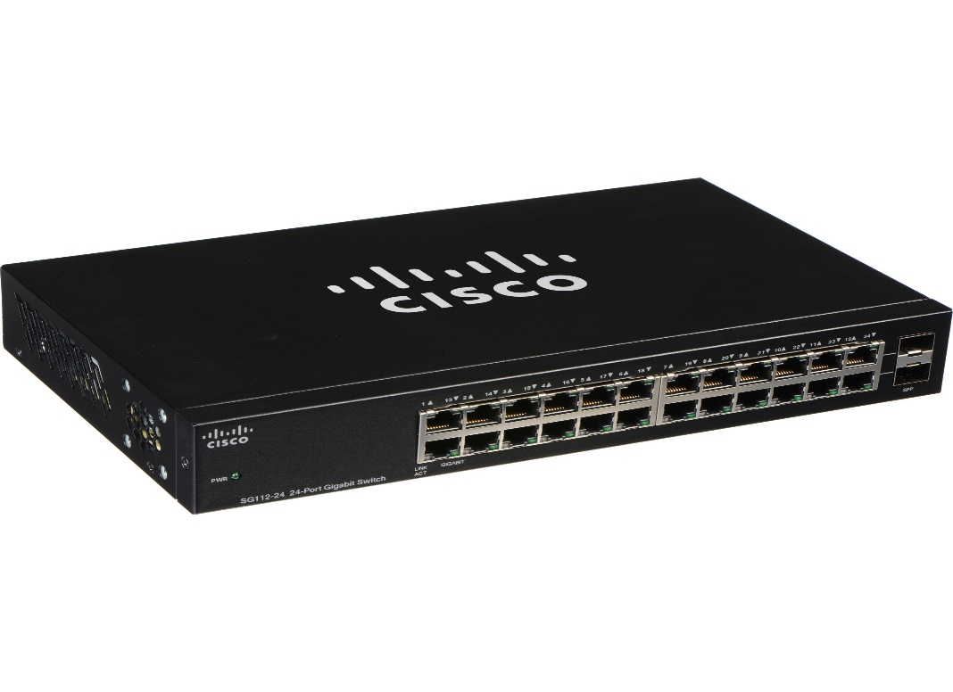
Figure 17-Switch
Gateway: A gateway, as the name suggests, is a passage to connect two networks that may work upon different networking models. They work as messenger agents that take data from one system, interpret it, and transfer it to another system. Gateways are also called protocol converters and can operate at any network layer. Gateways are generally more complex than switches or routers. A gateway is also called a protocol converter.
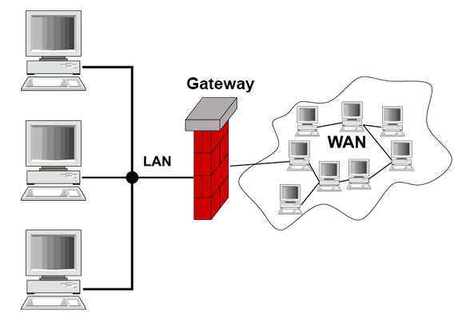
Figure 18-Gateway
Router: A router is a device like a switch that routes data packets based on their IP addresses. The router is mainly a Network Layer device. Routers normally connect LANs and WANs and have a dynamically updating routing table based on which they make decisions on routing the data packets. The router divides the broadcast domains of hosts connected through it

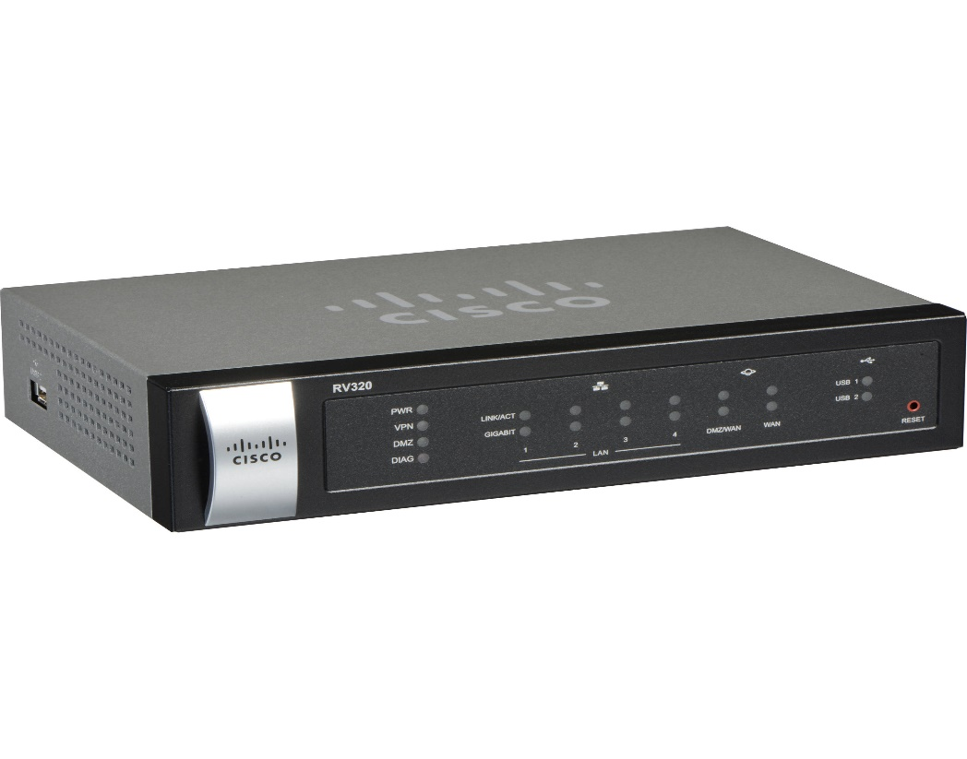
Figure 19-Router
NIC: NIC or network interface card is a network adapter that is used to connect the computer to the network. It is installed in the computer to establish a LAN. It has a unique id that is written on the chip, and it has a connector to connect the cable to it. The cable acts as an interface between the computer and the router or modem. NIC card is a layer 2 device which means that it works on both the physical and data link layers of the network model.
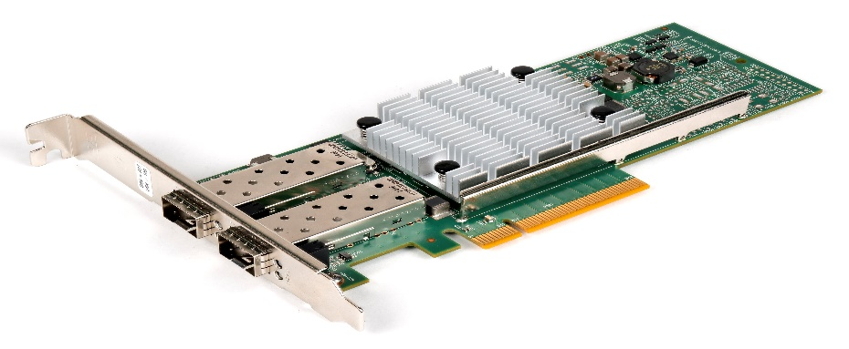
Figure 20-Network Interface Card

EXPERIMENT: 3
AIM: Practically implement and test the cross-wired cable and straight through cable using clamping tool and network lab cable tester.
Apparatus: RJ-45 connector, Crimping Tool, Twisted pair Cable
Procedure: To do these practical following steps should be done

RJ45 Connector
RJ45 stands for Registered Jack 45 and is the most commonly used connector in wired networks. The jacks are mainly used to connect to the Local Area Network (LAN). It was earlier devised for telephones but is now widely used in Ethernet Networking. The 45 in RJ45 basically stands for the listing number. The width of RJ45 is usually greater than that of the telephone cables or other Registered Jacks. Compared to additional jacks the bandwidth provided by these is high and the range is usually 10 Gbps. Because of speed and enhanced security, they are used to connect personal computers to servers, routers etc. These jacks are mostly used in Star Topology.
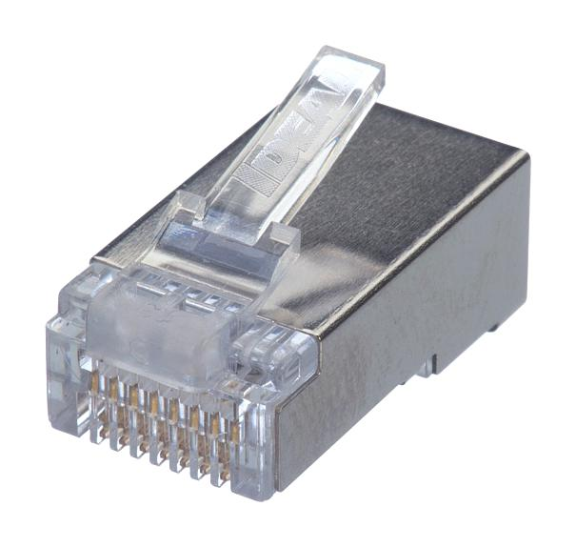
Figure 3.1- Connector
Crimping Tool
A crimping tool is a device that is used to make cold weld joints between wires and a connector through deforming one or both of them to hold the other. A special connector is used to join metals together. The weld joint properties (mechanical and electrical) are strong as the parent materials when the tool works and offer some result, which is known as crimp. An instance of crimping is to affixing a connector to the end of a wire. For example, a crimping tool is used to create phone cable sand network cables to combine RJ-11 and RJ-45 connectors to both ends of the phone or Cat 5 cable.


Figure 3.2- Crimping Tool
How to prepare Cross wired connection

Materials Needed:
- Ethernet cable
- RJ-45 connectors
- Crimping tool

Steps:
- Strip the Cable:
  - Use the wire stripper to remove about 2 inches of the outer jacket from both ends of the Ethernet cable, exposing the twisted pairs inside.
- Untwist and Arrange Wires:
  - Untwist the pairs and arrange them according to the T568A and T568B standards. For a crossover cable, one end should follow the T568A standard and the other end should follow the T568B standard.
- Trim the Wires:
  - Trim the wires to ensure they are all the same length, about half an inch from the cut jacket.
- Insert Wires into RJ-45 Connectors:
  - Carefully insert the wires into the RJ-45 connector, making sure each wire goes into the correct slot. The T568A standard should be on one end and the T568B standard on the other.
- Crimp the Connectors:
  - Use the crimping tool to crimp the RJ-45 connectors onto the cable. Ensure the wires are securely fastened inside the connector.
- Test the Cable:
  - Use a cable tester to ensure the crossover cable is working correctly.
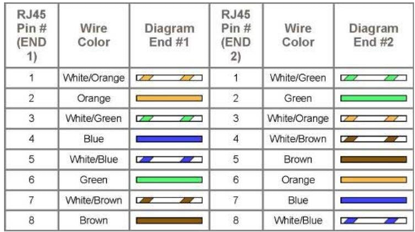
Figure 3.3- Diagram shows you how to prepare Cross wired connection

How to prepare straight through wired connection

Materials Needed:
- RJ-45 connectors
- Clamping (crimping) tool
- Twisted pair cable
- Cable stripper or cutter

Steps:
- Strip the Cable:
  - Use the cable stripper to remove about 2 inches of the outer jacket from both ends of the twisted pair cable. Be careful not to nick the inner wires.
- Untwist and Arrange Wires:
  - Untwist the pairs of wires and arrange them in the correct order. For a straight-through cable, the order should be the same on both ends. The standard wiring order is:
- Trim the Wires:
  - Trim the wires so they are all the same length, about 1/2 inch from the jacket.
- Insert Wires into RJ-45 Connector:
  - Carefully insert the wires into the RJ-45 connector, ensuring each wire goes into the correct slot. The flat side of the connector should be facing you, and the clip should be on the bottom.
- Crimp the Connector:
  - Insert the connector into the clamping tool and squeeze the tool firmly to crimp the connector onto the cable. This secures the wires in place and ensures a good connection.
- Repeat for the Other End:
  - Repeat the process for the other end of the cable, making sure the wiring order is the same.
- Test the Cable:
  - Use a cable tester to ensure the connections are correct and the cable is functioning properly.
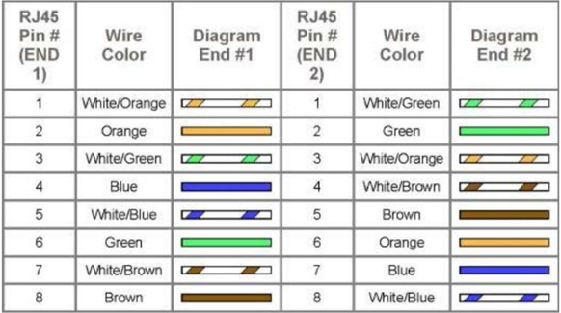
Figure 3.4- Diagram shows you how to prepare straight through wired connection
EXPERIMENT: 4
AIM: Familiarization with Packet Tracer Simulation tool/any other related tool.
Apparatus (Software): Cisco packet tracer.

Description: What is Cisco Packet Tracer?
Cisco Packet Tracer is Cisco's simulation software. It can be used to create complicated network typologies, as well as to test and simulate abstract networking concepts. It acts as a playground for you to explore networking and the experience is very close to what you see in computer networks.
Engineers prefer to test any protocols on Cisco Packet Tracer before implementing them. Also, Engineers who would like to deploy any change in the production network prefer to use Cisco Packet Tracer to first test the required changes and proceed to deploy if and only if everything is working as expected.
This makes the job easier for Engineers allowing them to add or remove simulated network devices, with a Command line interface and a drag and drop user interface.
You can download the tool from https://www.netacad.com by clicking on the Packet Tracer graphic and selecting the appropriate OS package, then you are good to play with it.
Packet Tracer is a networking simulation tool (as stated above) used for practice, discovery, and troubleshooting designed by Cisco. Cisco’s official website describes Packet Tracer as:
“A powerful network simulation program that allows students to experiment with network behavior and ask ‘what if’ questions.”
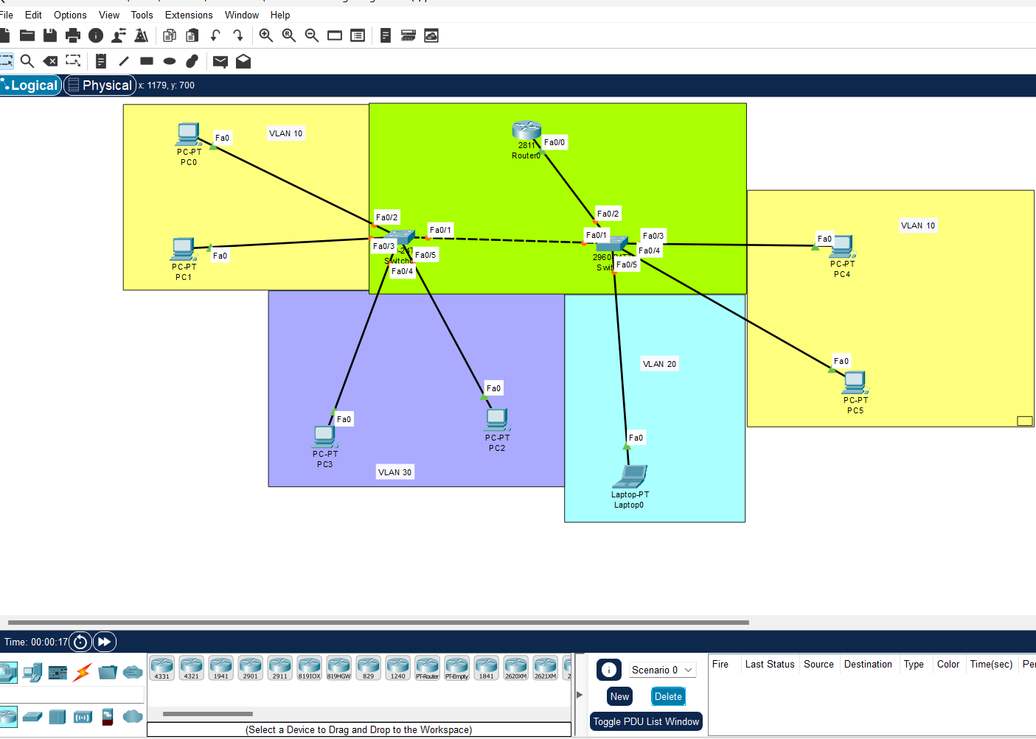
Figure 4.1- Cisco packet tracer
Installing Packet Tracer
Follow the below steps to install Packet Tracer
Step 1: Visit the official website of Netacad using any web browser.


Figure4.2- Netcad website
Step 2: Press the login button and select log in option.


Figure 4.3-Click Login
Step 3: Next screen will appear, click on the sign-up option.

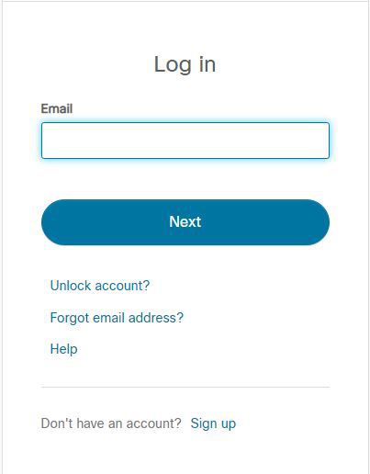
Figure 4.4 setup login
Step 4: Next screen will appear and will ask for email and password and other simple details, fill them and click on Register.
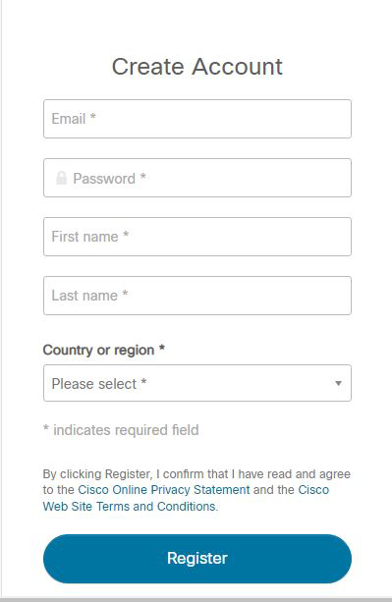
Figure 4.5 Create account
Step 5: Now the login screen appears again so fill in the Email id.
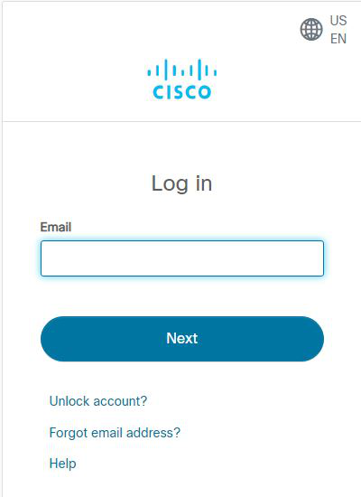
Figure 4.6- Email
Step 6: On the next screen enter the password and press the Login button.
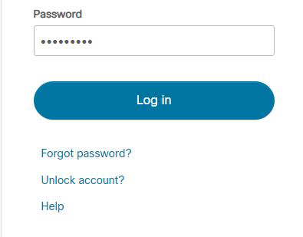
Figure 4.7- Password
Step 7: Dashboard will initialize, now click on Resources and choose Download Packet Tracer Option.
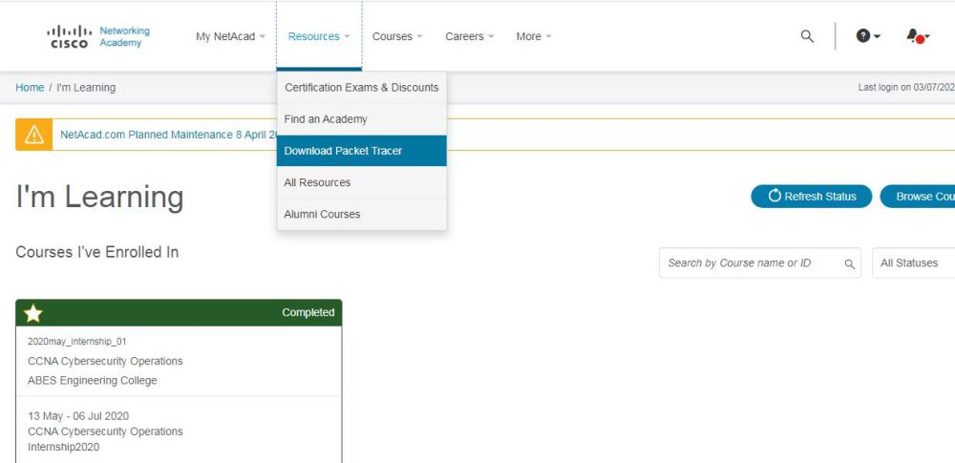
Figure 4.8- Download packet tracer
Step 8: On the next web page choose the operating system to download the packet tracer. Downloading will start automatically.
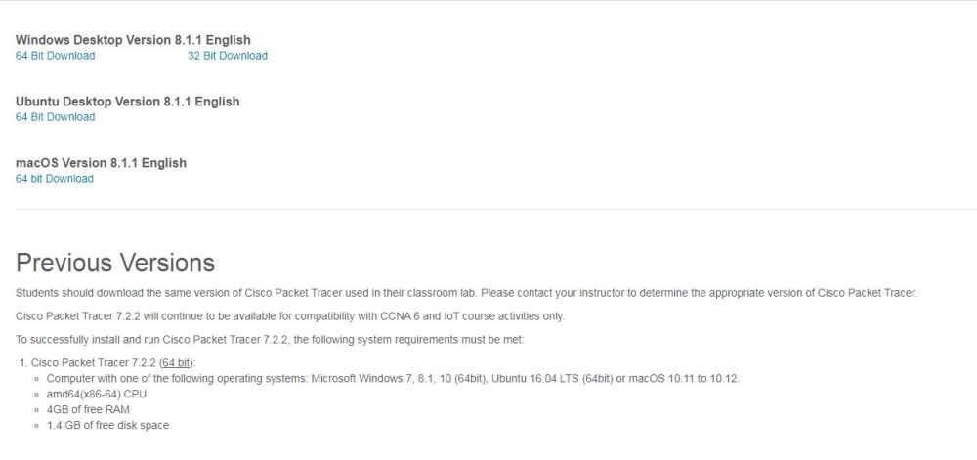
Figure 4.9- Select operating system
Step 9: Check for the executable file in your system and run it.
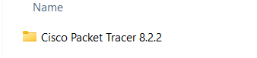
Figure 4.10- Executable file
Step 10: Next screen is of License Agreement so Click on I accept the license.
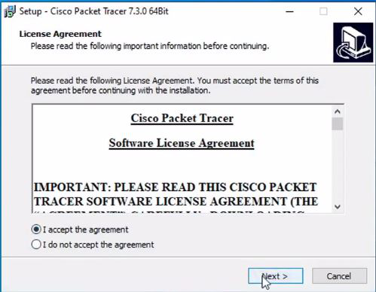
Figure 4.11-Licebse agreement
Step 11: Choose the installing location which has sufficient space.
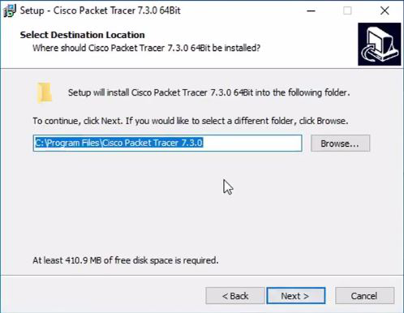
Figure 4.12-File location
Step 12: Now packet tracer is ready to install so click on the Install button.
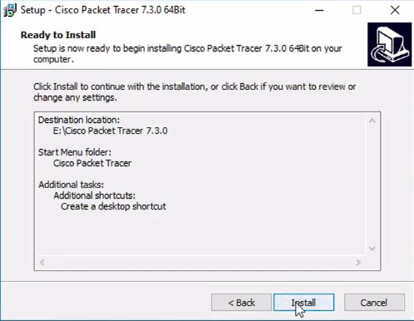
Figure 4.13-Create shortcut
Step 13: The installation process will start and will hardly take a minute.
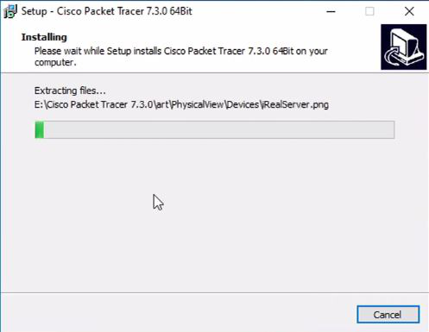
Figure 4.14-Installing
Step 14: Click on the Finish button to complete the installation.
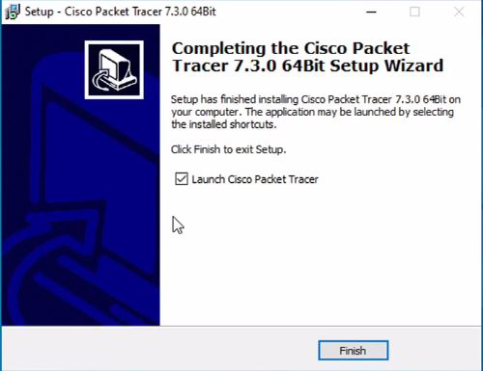
Figure 4.15-Setup
Step 15: An icon is created on the desktop so run it.

Figure 4.16- Icon
Step 16: Interface is initialized and the software is ready to use.
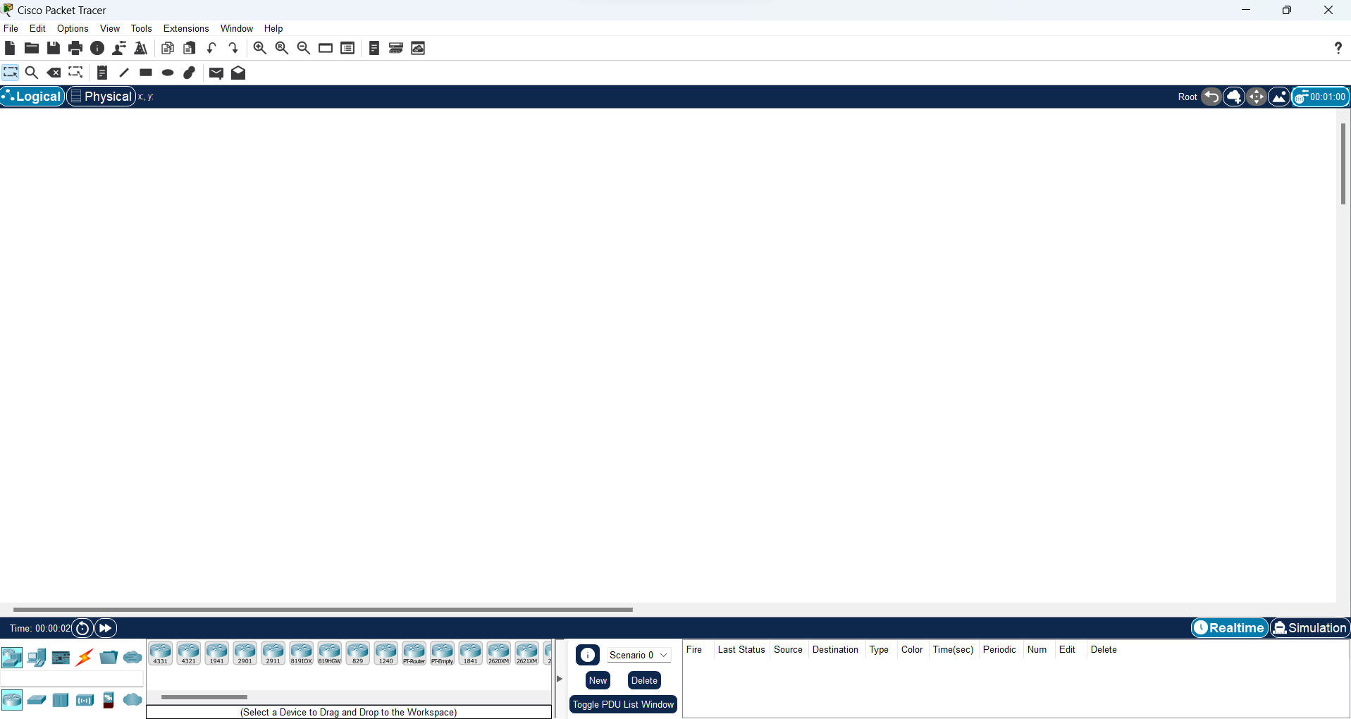
Figure 4.17- Cisco Packet Tracer Interface

EXPERIMENT: 5
AIM: Study and Implementation of IP Addressing Schemes.
Apparatus: Routers, Switches, Computers, Network cables.
Description: An IP address (Internet Protocol address) is a unique numerical label assigned to each device connected to a computer network that uses the Internet Protocol for communication. It serves two main functions:
Network Interface Identification: Identifies a specific device on a network.
Location Addressing: Provides the location of the device in the network, enabling data to be routed to and from it.

Types of IP Addresses
- IPv4: The older version, using a 32-bit address format (e.g., 192.0.2.1), allowing for about 4.3 billion unique addresses.
- IPv6: The newer version, using a 128-bit address format (e.g., 2001:0db8:85a3:0000:0000:8a2e:0370:7334), allowing for a vastly larger number of unique addresses.

What is an IPV4 Address?
An IPv4 address is a unique number assigned to every device that connects to the internet or a computer network. It’s like a home address for your computer, smartphone, or any other device, allowing it to communicate with other devices.
- Format: An IPv4 address is written as four numbers separated by periods, like this: 192.168.1.1. Each number can range from 0 to 255.
- The IPv4 address is divided into two parts: Network ID and Host ID.
- Purpose: The main purpose of an IPv4 address is to identify devices on a network and ensure that data sent from one device reaches the correct destination.
- Example: When you type a website address into your browser, your device uses the IPv4 address to find and connect to the server where the website is hosted.

Representation of IPV4 Address
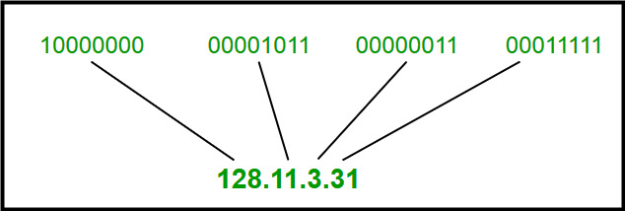
Figure 5.1- IPV4

Classful Addressing
The 32-bit IP address is divided into five sub-classes. These are given below:
- Class A
- Class B
- Class C
- Class D
- Class E

Each of these classes has a valid range of IP addresses. Classes D and E are reserved for multicast and experimental purposes respectively. The order of bits in the first octet determines the classes of the IP address.
The class of IP address is used to determine the bits used for network ID and host ID and the number of total networks and hosts possible in that particular class. Each ISP or network administrator assigns an IP address to each device that is connected to its network.

Class A
IP addresses belonging to class A are assigned to the networks that contain a large number of hosts.
- The network ID is 8 bits long.
- The host ID is 24 bits long.
The higher-order bit of the first octet in class A is always set to 0. The remaining 7 bits in the first octet are used to determine network ID. The 24 bits of host ID are used to determine the host in any network. The default subnet mask for Class A is 255.x.x.x. Therefore, class A has a total of: 2^24 – 2 = 16,777,214 host ID
IP addresses belonging to class A ranges from 0.0.0.0 – 127.255.255.255.
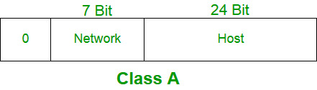

Class B
IP address belonging to class B is assigned to networks that range from medium-sized to large-sized networks.
- The network ID is 14 bits long.
- The host ID is 16 bits long.
The higher-order bits of the first octet of IP addresses of class B are always set to 10. The remaining 14 bits are used to determine the network ID. The 16 bits of host ID are used to determine the host in any network. The default subnet mask for class B is 255.255.x.x. Class B has a total of:
- 2^14 = 16384 network address
- 2^16 – 2 = 65534 host address
IP addresses belonging to class B ranges from 128.0.0.0 – 191.255.255.255.
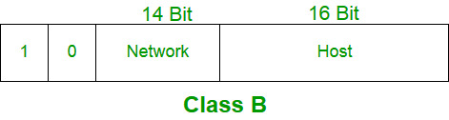

Class C
IP addresses belonging to class C are assigned to small-sized networks.
- The network ID is 24 bits long.
- The host ID is 8 bits long.
The higher-order bits of the first octet of IP addresses of class C is always set to 110. The remaining 21 bits are used to determine the network ID. The 8 bits of host ID are used to determine the host in any network. The default subnet mask for class C is 255.255.255.x. Class C has a total of:
- 2^21 = 2097152 network address
- 2^8 – 2 = 254 host address
IP addresses belonging to class C range from 192.0.0.0 – 223.255.255.255.
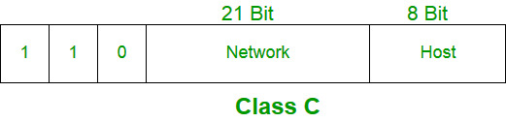

Class D
IP address belonging to class D is reserved for multi-casting. The higher-order bits of the first octet of IP addresses belonging to class D is always set to 1110. The remaining bits are for the address that interested hosts recognize.
Class D does not possess any subnet mask. IP addresses belonging to class D range from 224.0.0.0 – 239.255.255.255.
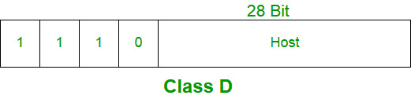

Class E
IP addresses belonging to class E are reserved for experimental and research purposes. IP addresses of class E range from 240.0.0.0 – 255.255.255.255. This class doesn’t have any subnet mask. The higher-order bits of the first octet of class E are always set to 1111.
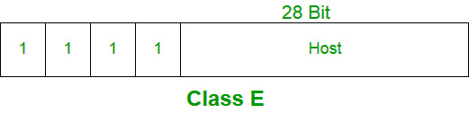

Range of Special IP Addresses
- Loopback Addresses:
  - Range: 127.0.0.0 to 127.255.255.255
  - Usage: Used for testing and diagnostics on the local machine. The most common address is 127.0.0.1, often referred to as “localhost.”
- Private IP Addresses:
  - Class A: 10.0.0.0 to 10.255.255.255
  - Class B: 172.16.0.0 to 172.31.255.255
  - Class C: 192.168.0.0 to 192.168.255.255
  - Usage: Used within private networks and not routable on the public internet

- Link-Local Addresses:
  - Range: 169.254.0.0 to 169.254.255.255
  - Usage: Automatically assigned by a device when a DHCP server is not available. Used for communication within a local network segment.
- Multicast Addresses:
  - Range: 224.0.0.0 to 239.255.255.255
  - Usage: Used for multicast groups, allowing a single packet to be delivered to multiple destinations.
- Broadcast Address:
  - Range: 255.255.255.255
  - Usage: Used to send a packet to all hosts on the local network.
- Reserved Addresses:
  - Range: 240.0.0.0 to 255.255.255.254
  - Usage: Reserved for future use or for experimental purposes.

What is an IPV6 Address?
An IPv6 address is a 128-bit alphanumeric identifier used to uniquely identify devices on a network, enabling them to communicate with each other across the internet. Unlike its predecessor, IPv4, which uses 32-bit addresses and is limited to around 4.3 billion unique addresses. This vast increase is crucial for meeting the demands of a world where billions of devices, from smartphones to IoT devices, require unique IP addresses.
IPv6 is represented by the below representation

1000:0ac3:22a2:0000:0000:4b3c:0504:1234
Address Structure
- Length: IPv6 addresses are 128 bits long, compared to IPv4’s 32 bits.
- Format: Written as eight groups of four hexadecimal digits, separated by colons (e.g., 2001:0db8:85a3:0000:0000:8a2e:0370:7334).

Address Types
- Unicast:
  - Purpose: Identifies a single interface.
  - Usage: Packets sent to a unicast address are delivered to the specific interface.
- Anycast:
  - Purpose: Assigned to multiple interfaces, usually on different nodes.
  - Usage: Packets sent to an anycast address are delivered to the nearest interface, as determined by the routing protocol.
- Multicast:
  - Purpose: Identifies multiple interfaces.
  - Usage: Packets sent to a multicast address are delivered to all interfaces that have joined the corresponding multicast group.

Address Notation
- Zero Compression: Consecutive sections of zeros can be replaced with : (e.g., 2001:0db8:0000:0000:0000:0000:1428:57ab can be written as 2001:0db8::1428:57ab).
- Leading Zeroes: Leading zeroes in any section can be omitted (e.g., 2001:0db8:0000:0000:0000:0000:1428:57ab can be written as 2001:db8::1428:57ab).

EXPERIMENT: 6
AIM: Creation of Simple Networking topologies using hubs and switches.
Apparatus (Software): Cisco packet tracer.

Procedure: Implementing Star Topology using Cisco Packet Tracer.
A star topology for a Local Area Network (LAN) is one in which each node is connected to a central connection point, such as a hub or switch. Whenever a node tries to connect with another node then the transmission of the message must be happening with the help of the central node. The best part of star topology is the addition and removal of the node in the network but too many nodes can cause suffering to the network.

Steps Implementing Star Topology using Cisco Packet Tracer:
Step 1: We have taken a switch and linked it to six end devices.
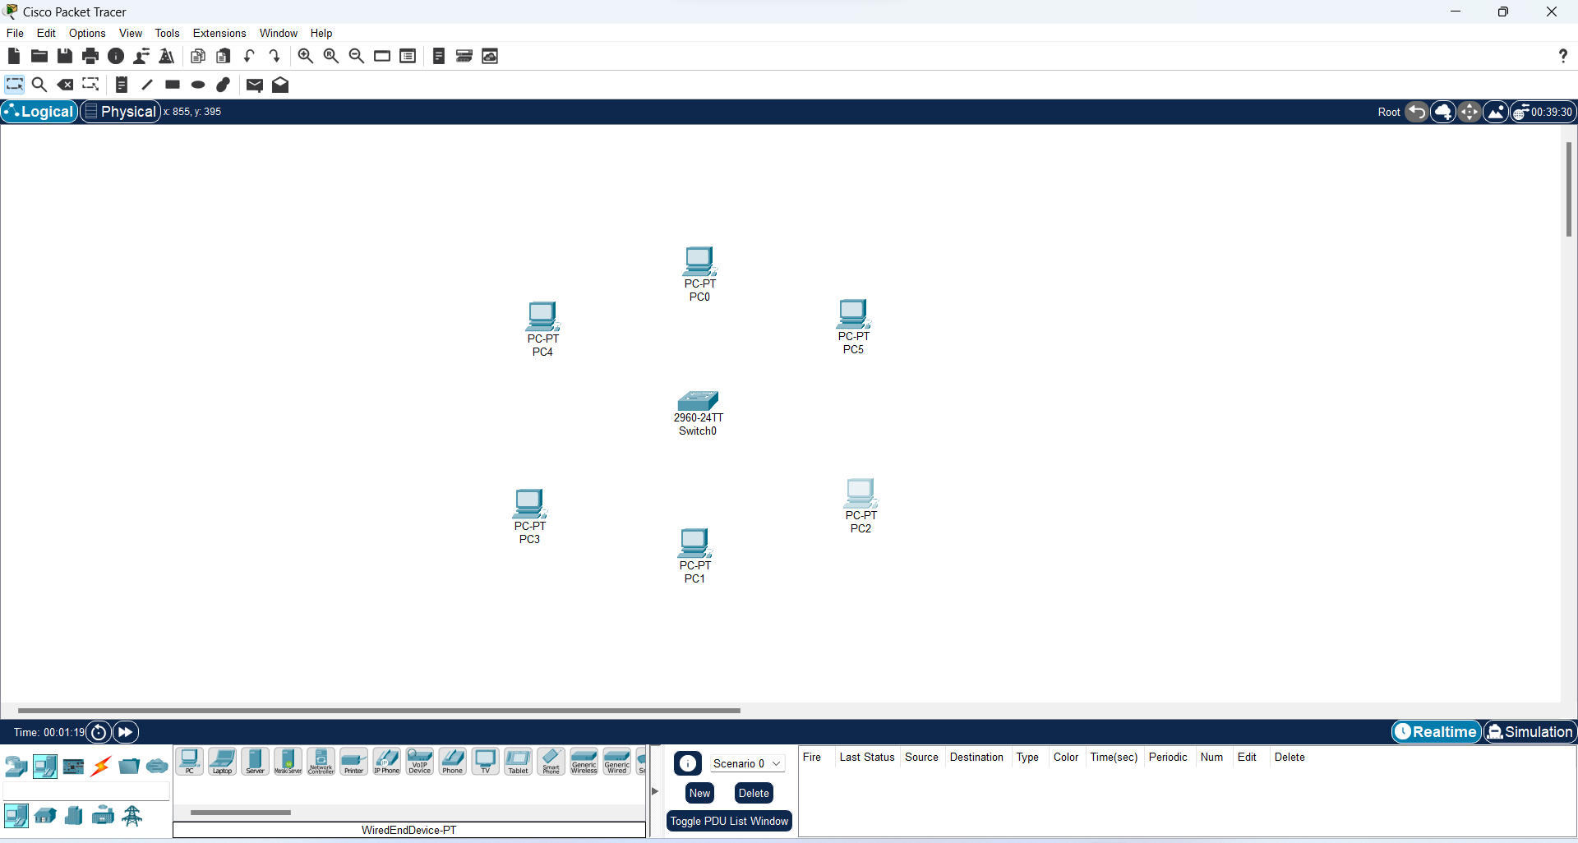
Figure 6.1- Network Creation
Step 2: Link every device with the switch.
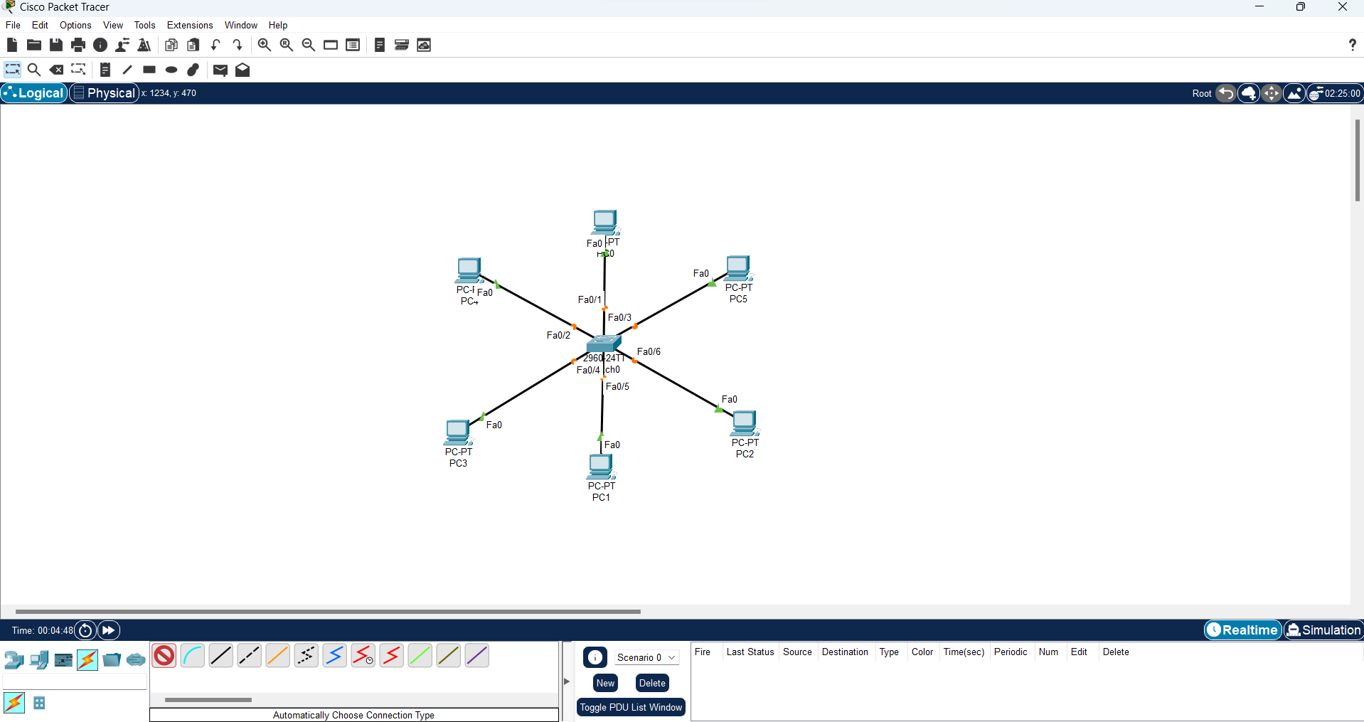
Figure 6.2- Connection
Step 3: Provide the IP address to each device.
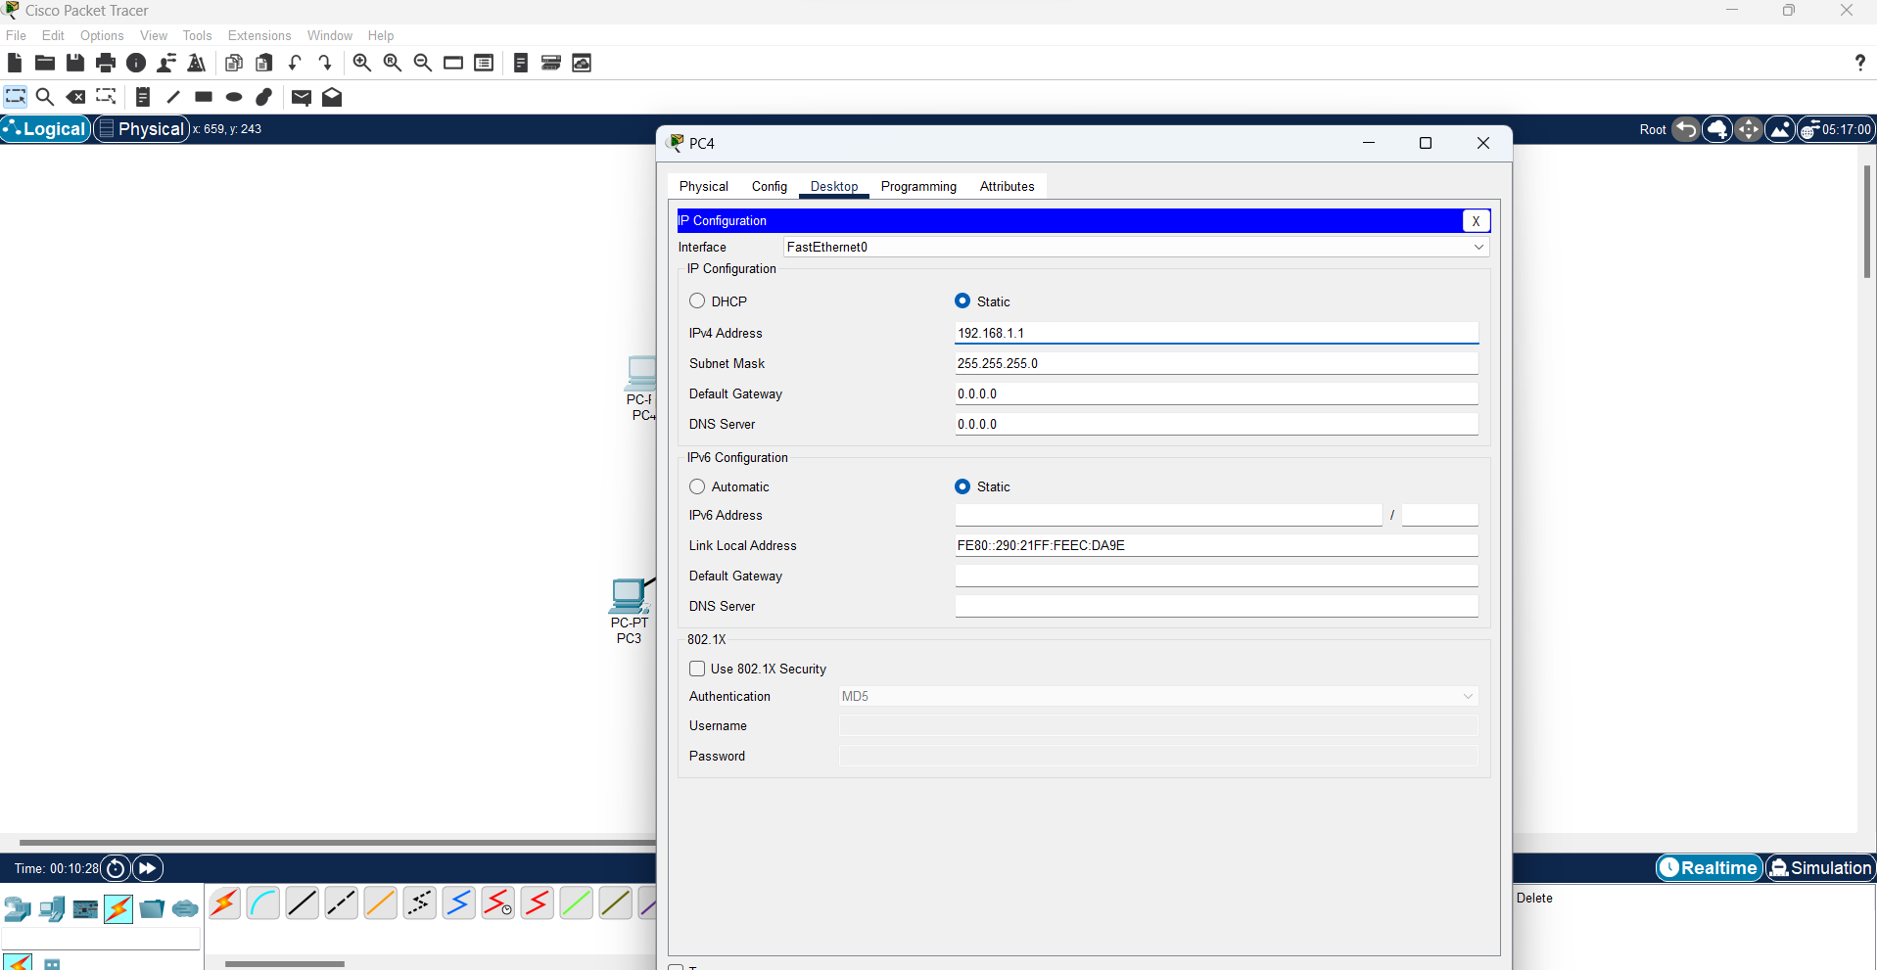
Figure 6.3- Assigning IP Addresses
Step 4: Transfer message from one device to another and check the Table for Validation.
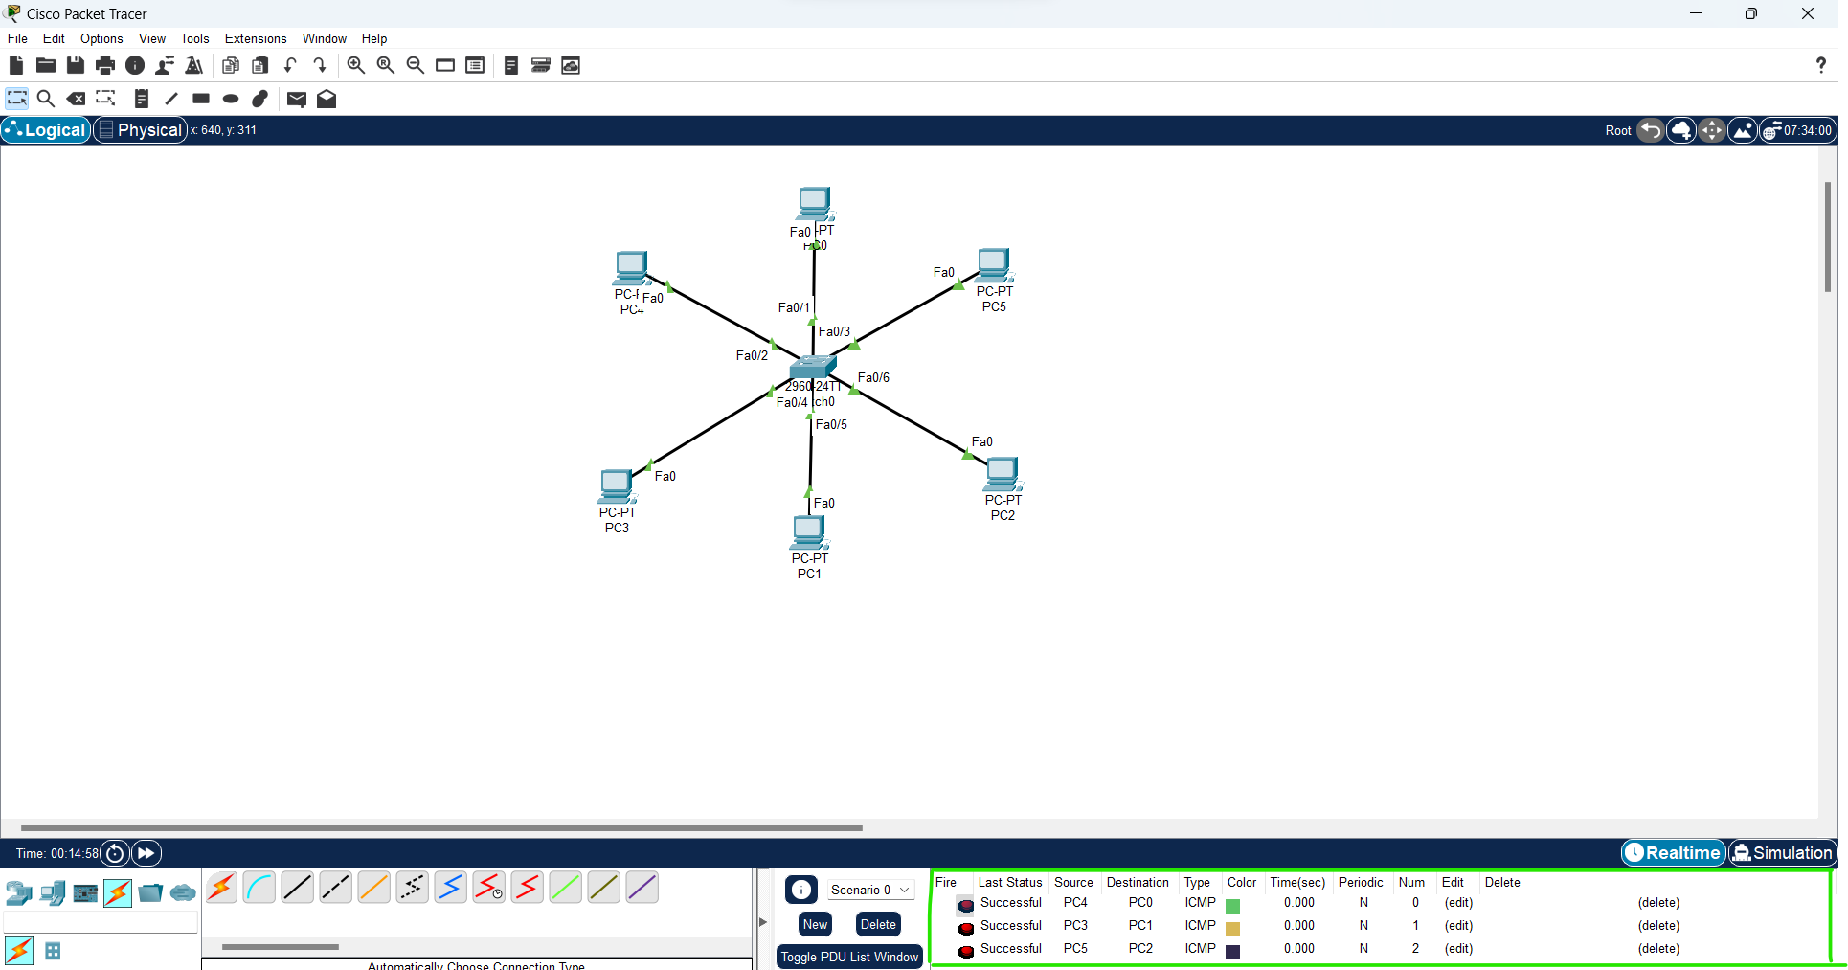
Figure 6.4- Packet Delivery
Now to check whether the connections are correct
Command:
To check the ip address of a given device, On command prompt of a device write:
- ipconfig
To do ping one terminal of one device and run the following command:
- Ping <ip address of any device
Demonstration:
- To check the ip of a device
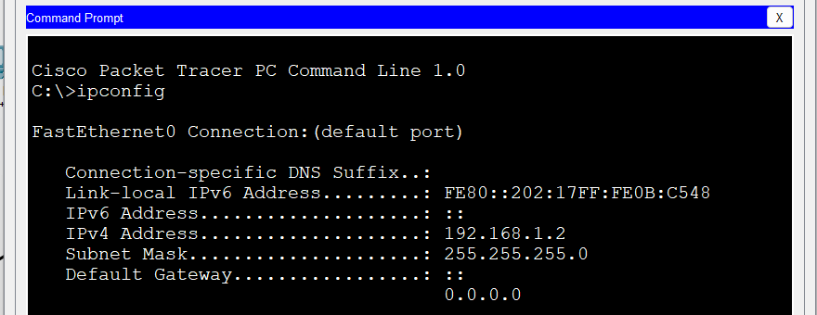
Figure 6.5- ipconfig command
- To ping a network
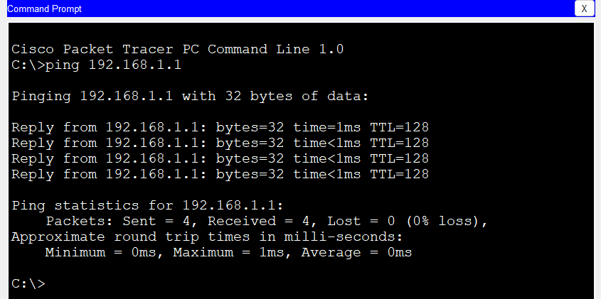
Figure 6.6-ping command

EXPERIMENT: 7
AIM: Study and implementation of various router configuration commands.
Apparatus (Software): Cisco packet tracer.
Description: A router is a layer 3 device used to forward packets from one network to another. It forwards the packet through one of its ports on the basis of destination IP address and the entry in the routing table. By using a routing table, it finds an optimized path between the source and destination network.
Administrative Configuration:

Basic Router Configuration Commands

Entering Global Configuration Mode
Router> enable
Router# configure terminal
This command sequence allows you to enter the global configuration mode, where you can make changes to the router’s settings.
Giving hostname to the router –
Once in the global configuration mode, type “hostname” followed by a space and the “new router name”. To differentiate your Router from other devices in the network, you should configure a Hostname for your device. It is used to set a name to a device stating an identity to a device. This is important as these hostnames are used in WAN for authentication purposes.
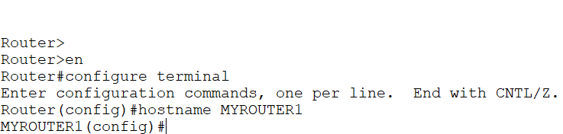
Figure 7.1- Hostname
Applying banners –
These are specifically used to give a small security notice to the user who wants to access the router. We can customize it According to our needs as like asking for credentials needed for the login.
We can configure two types of banner on routers; MOTD banner and Exec banner.
banner exec command is not available in packet tracer. You can practice with banner motd command. Both commands work in same manner. Only the difference between these commands is the place of display. MOTD banner will display before the login. An EXEC banner will display after the authentication Banner ocess and before the exec mode.
Figure 7.2- Applying Banner
Setting password –
There are five passwords used to secure a Cisco device:
enable password –
The enable password is used for securing privilege mode. This password will be shown in clear text by the command “show running-configuration”. These are replaced by secret passwords nowadays.
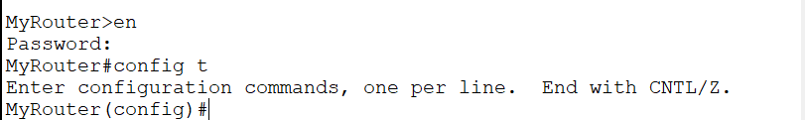
Figure 7.3- Enable Password
Enable secret password –
This is also used for securing privilege mode but the difference is that it will be displayed as a cipher in “show running-configuration”. This password will override the enable password if both passwords are set.
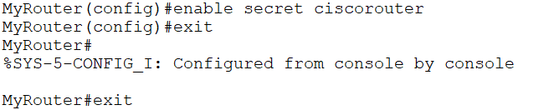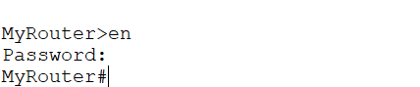
Figure 7.4- Enable Secret
line console password –
When a user will take access through the console port then this password will be asked.
Command | Description
Router(config)#line console 0 | Move in console line mode
Router(config-line)#password console | Set console line password to CNN
Router(config-line)#login | Enable password authentication for console line

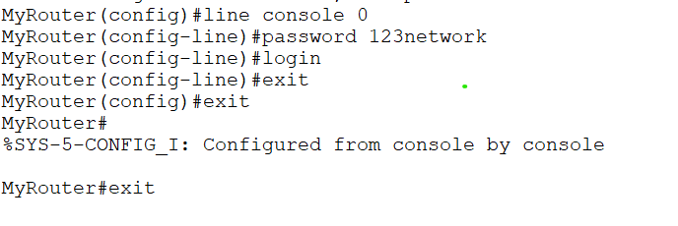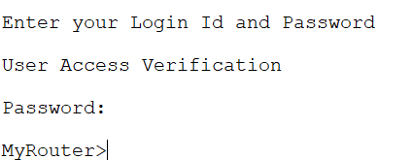
Figure 7.5- line console

auxiliary password –
This password will secure the aux port.
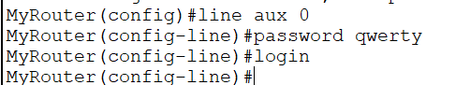
Figure 7.6- aux password
Assigning IP address to a router’s interface –
As we know the router is a layer 3 device therefore every port of a router should have an IP address to work. By default, a router’s port has no IP address and its line protocol is also down.
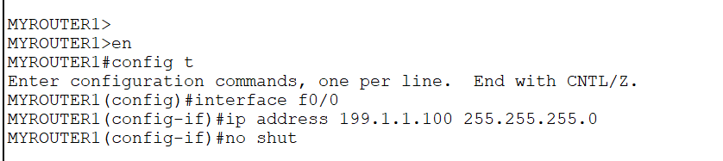
Figure 7.7- IP Assigning
Here first we have to specify the router’s interface on which we want to give an IP address. Then we will enter interface mode where we will give an IP address as shown followed by its subnet mask (255.255.255.0). Then, we have made the router port administratively up by no shut command.
Copying and erasing configuration –
We can manually copy the running configuration (configuration in RAM) to startup configuration (configuration in NVRAM). Therefore, when the next time router will boot up, it will load the configuration that we have copied (as by default the configuration of NVRAM is loaded).
router#copy running-config startup-config
To erase the configuration of NVRAM, use the command
router#erase startup-config
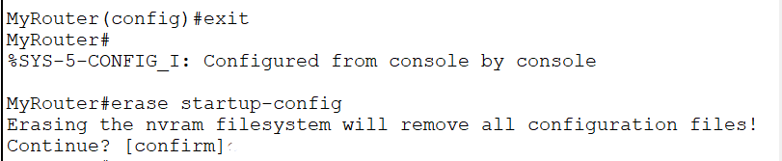
Figure 7.8- Erasing configuration

EXPERIMENT: 8
AIM: Simulation of web traffic in Packet Tracer.
Apparatus (Software): Cisco packet tracer.

Description: Web traffic refers to the flow of data between users (clients) and web servers over the internet. It encompasses all the data sent and received by users when they interact with websites. Here’s a breakdown of the key components and concepts:

Key Components of Web Traffic
- Clients:
  - Web Browsers: Software like Chrome, Firefox, or Safari that users use to access websites.
  - Devices: Computers, smartphones, tablets, etc., that run web browsers.
- Servers:
  - Web Servers: Computers that host websites and serve web pages to clients upon request.
  - Database Servers: Servers that store and manage data for websites.
- Network Infrastructure:
  - Routers and Switches: Devices that direct data packets between clients and servers.
  - Internet Service Providers (ISPs): Companies that provide internet access to clients and servers.
Simulation of Web Traffic
Step1: Design a LAN network using pc, server and switch in cisco packet tracer.
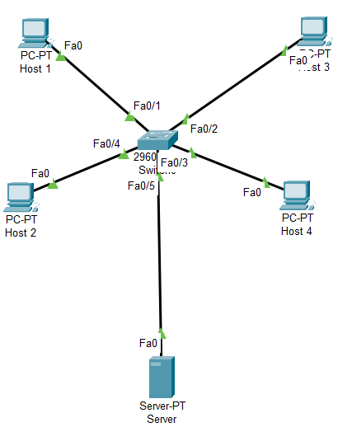
Figure 8.1 Design of network

Step2: Assigning IP addresses to pc and server.
Host 1: 192.168.0.1 Subnet mask 255.255.255.0
Host 2: 192.168.0.2 Subnet mask 255.255.255.0
Host 3: 192.168.0.3 Subnet mask 255.255.255.0
Host 4: 192.168.0.4 Subnet mask 255.255.255.0
Server: 192.168.0.250 Subnet mask 255.255.255.0

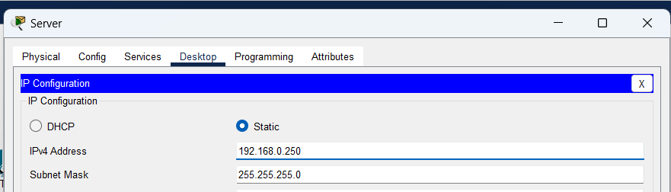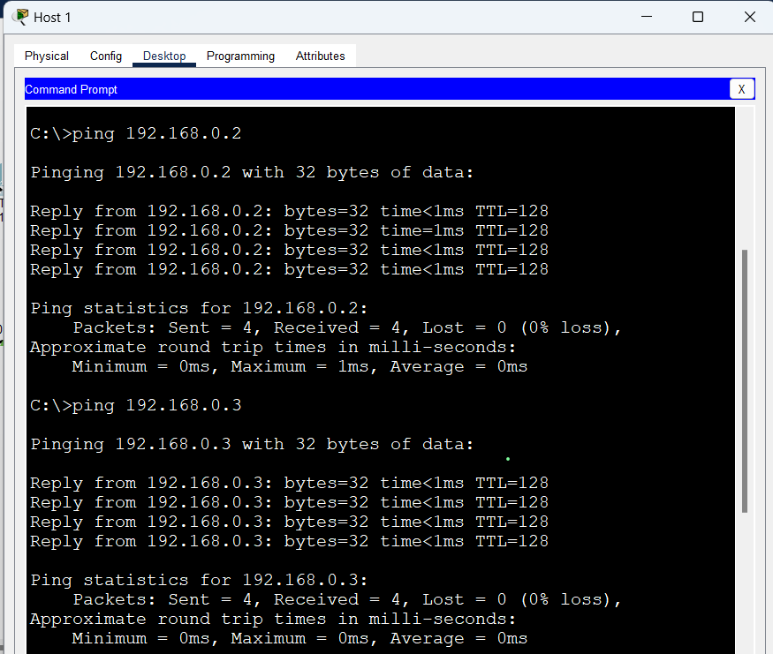
Figure 8.2 IP Assigning
Step3: Configure a server as web server, to display an appropriate web page, where web server is acting as both http and https.
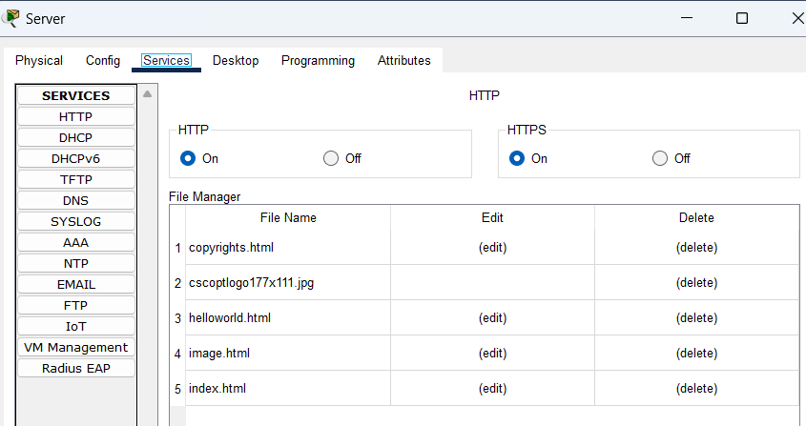
Figure 8.3: Configuring the server
Step4: Test the web server with http protocol, from any host.
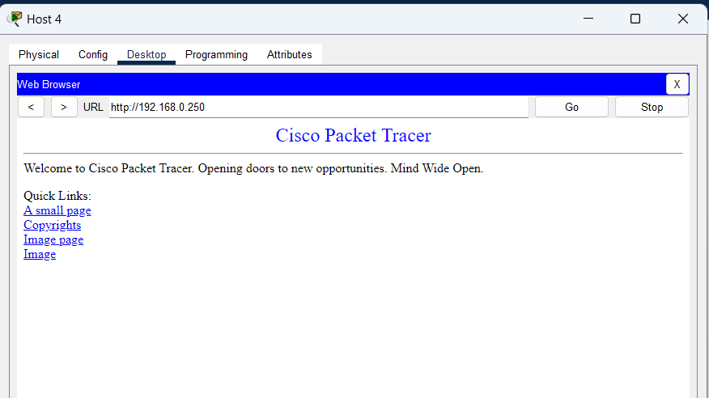
Figure 8.4 Testing web server
Step5: Test the web server with https protocol, from any host.
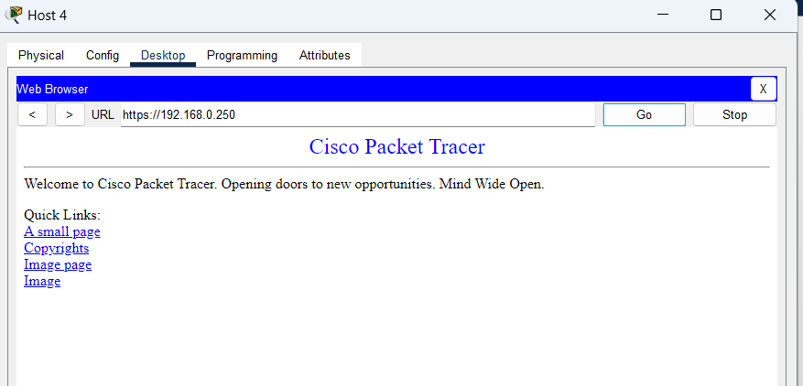
Figure 8.5 https protocol
Step6: Simulation of http protocol.
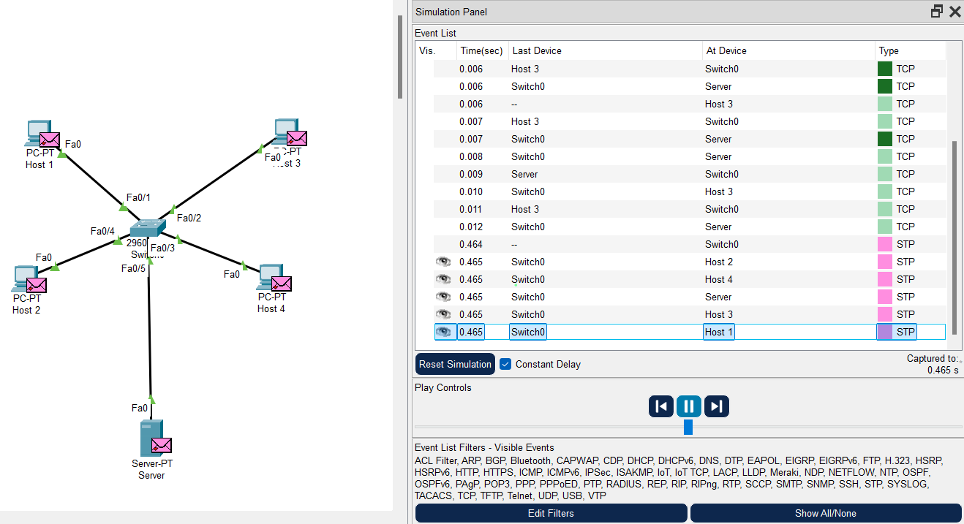
Figure 8.6 simulation of http protocol
Step7: Simulation of https protocol.
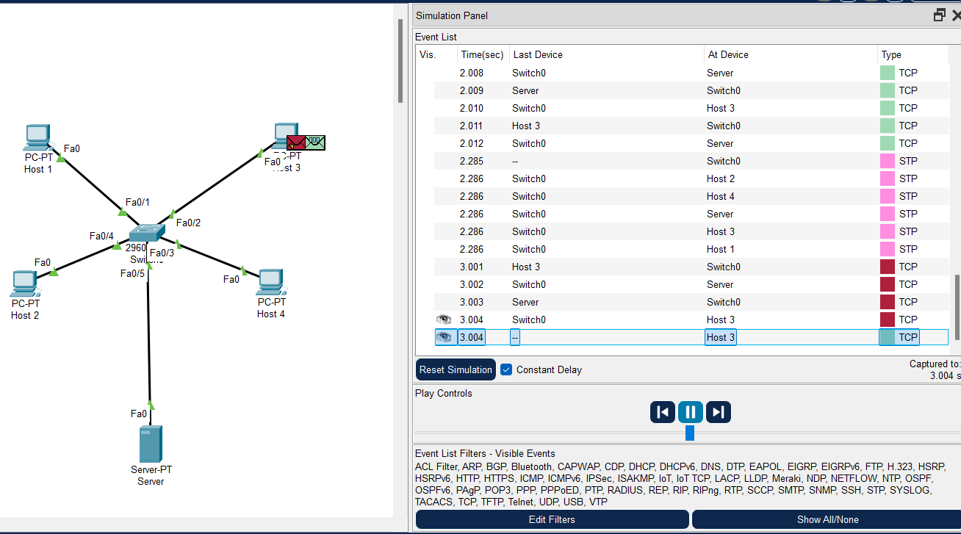
Figure 8.7 simulation of https protocol

EXPERIMENT: 9
AIM: Creation of Networks using routers.
Apparatus (Hardware): Router, Switches, Cable, Pc, Cisco Packet Tracer(software)
Description: What is a Router?
A Router is a networking device that forwards data packets between computer networks. One or more packet-switched networks or subnetworks can be connected using a router. By sending data packets to their intended IP addresses, it manages traffic between different networks and permits several devices to share an Internet connection.
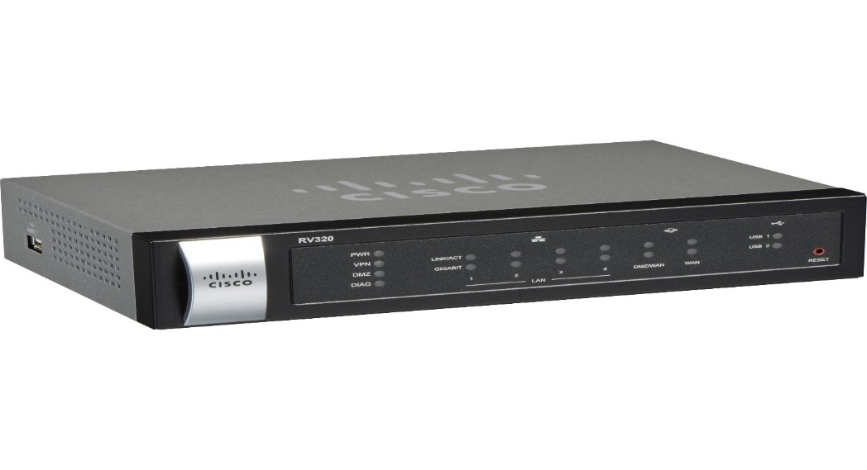
Figure 9.1 Router

How Does Router Work?
- A router determines a packet’s future path by examining the destination IP address of the header and comparing it to the routing database. The list of routing tables outlines how to send the data to a specific network location. They use a set of rules to determine the most effective way to transmit the data to the specified IP address.

- To enable communication between other devices and the internet, routers utilize a modem, such as a cable, fiber, or DSL modem. Most routers include many ports that can connect a variety of devices to the internet simultaneously. In order to decide where to deliver data and where traffic is coming from, it needs routing tables.

- A routing table primarily specifies the router’s default path. As a result, it might not determine the optimum path to forward the data for a particular packet. For instance, the office router directs all networks to its internet service provider through a single default channel.

- Static and dynamic tables come in two varieties in the router. The dynamic routing tables are automatically updated by dynamic routers based on network activity, whereas the static routing tables are configured manually.

Procedure:
We will create a simple network using router in cisco packet tracer. Now we will create a simple network using router and perform some configuration.

Steps to create a network:

Step 1: Launch Packet Tracer.
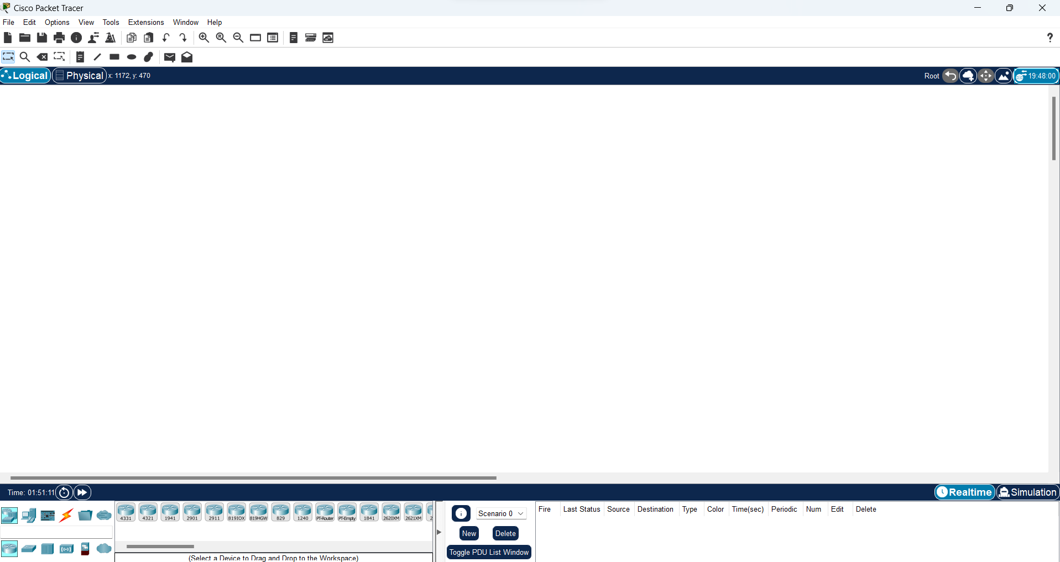
Figure 9.2 Launch packet tracer
Step2: Constructing the network.
Select a router and place it anywhere in a workspace.
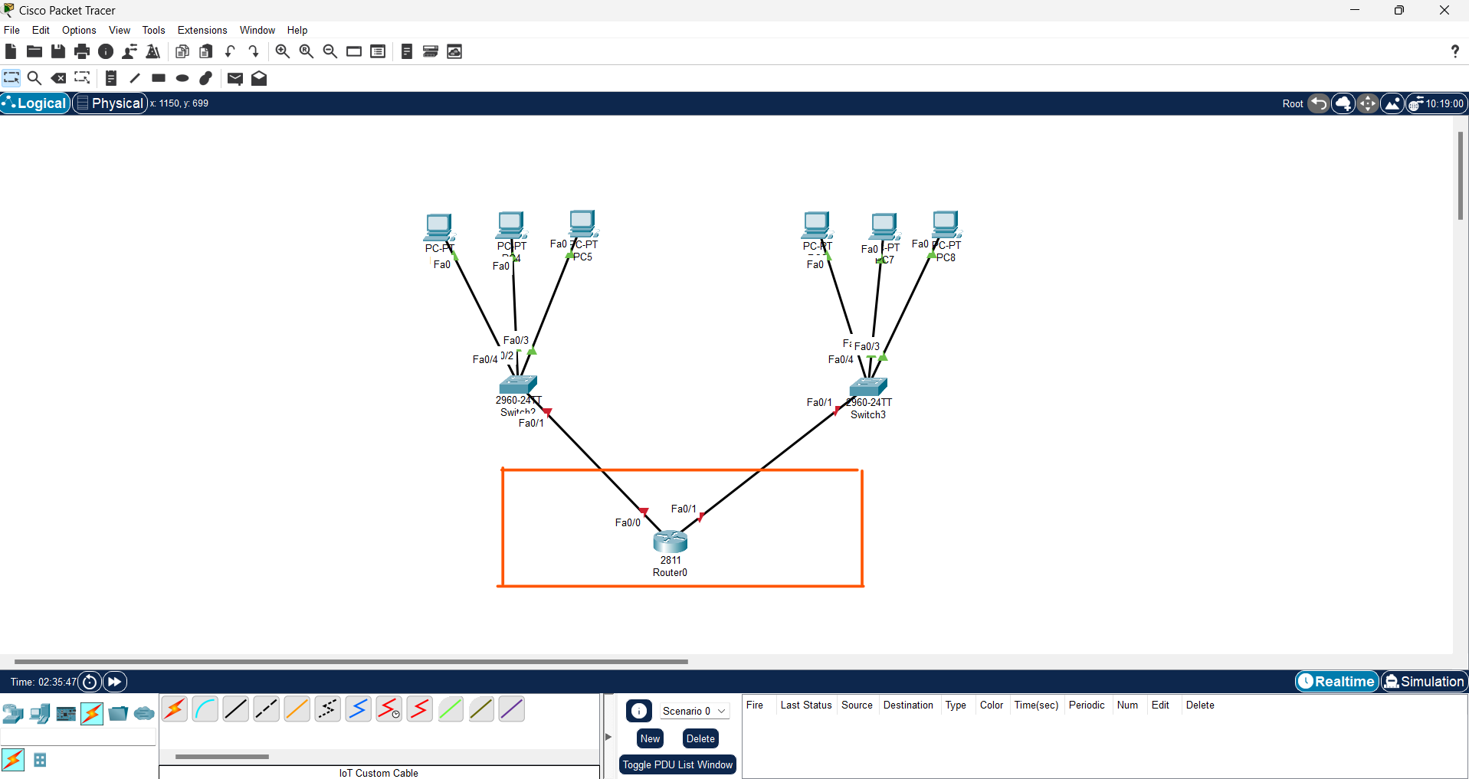
Figure 9.2 Placing router

Step3: Activate the interface connecting with router.
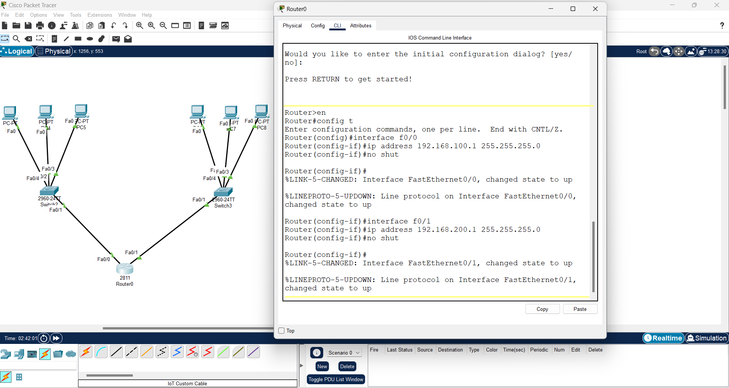
Figure 9.3 Activate interface
Step4: Assigning IP addresses to computers in a network.
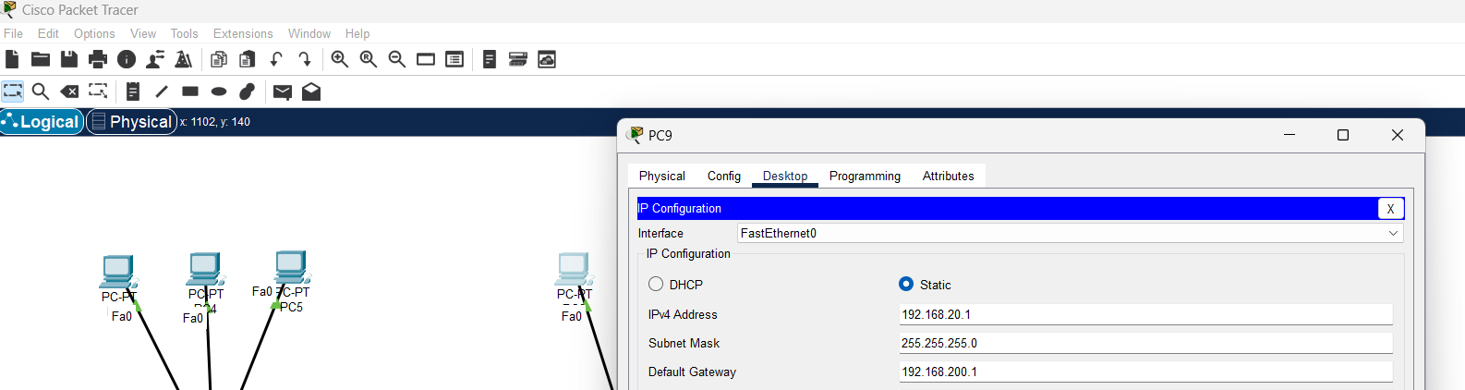
Figure 9.4 Assigning IP

Step5: Ping the computer to a router.
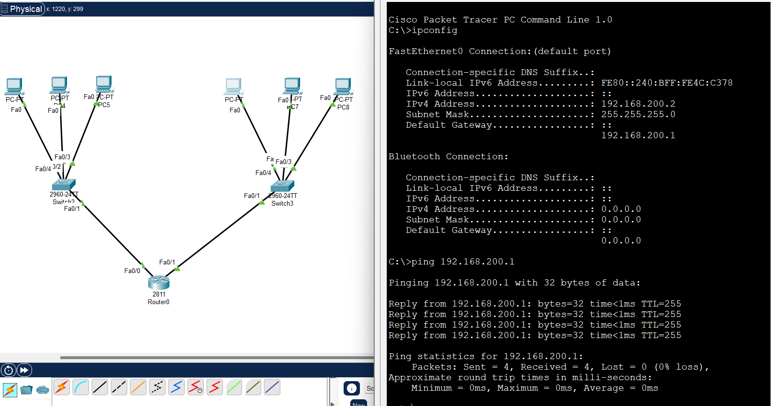
Figure 9.5 Ping a network

EXPERIMENT: 10
AIM: Configuring networks using the concept of subnetting.
Apparatus (Hardware): Router, Switches, Cable, Pc, Cisco Packet Tracer(software)
Description: What is Subnetting?
When a bigger network is divided into smaller networks, to maintain security, then that is known as Subnetting. So, maintenance is easier for smaller networks. For example, if we consider a class A address, the possible number of hosts is 224 for each network, it is obvious that it is difficult to maintain such a huge number of hosts, but it would be quite easier to maintain if we divide the network into small parts.

Uses of Subnetting
- Subnetting helps in organizing the network in an efficient way which helps in expanding the technology for large firms and companies.
- Subnetting is used for specific staffing structures to reduce traffic and maintain order and efficiency.
- Subnetting divides domains of the broadcast so that traffic is routed efficiently, which helps in improving network performance.
- Subnetting is used in increasing network security.

Reserve IP classes, network bits, and host bits
Each IP address belongs to a predefined IP class. There are five predefined IP classes; A, B, C, D, and E. From these classes, classes D and E are reserved and cannot be used in Subnetting.
In classes A, B, and C, the first 8, 16, and 24 bits are reserved for the network portion, respectively. These classes also reserve the last two bits for the host portion. We can not use reserve bits for subnetting.
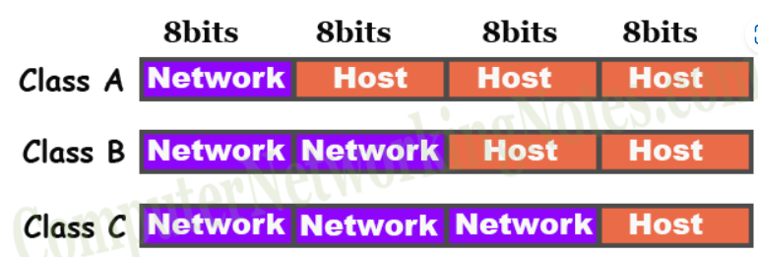

Subnetting Implementation in Cisco Packet Tracer
Step 1: First, open the Cisco packet tracer desktop and select the devices.
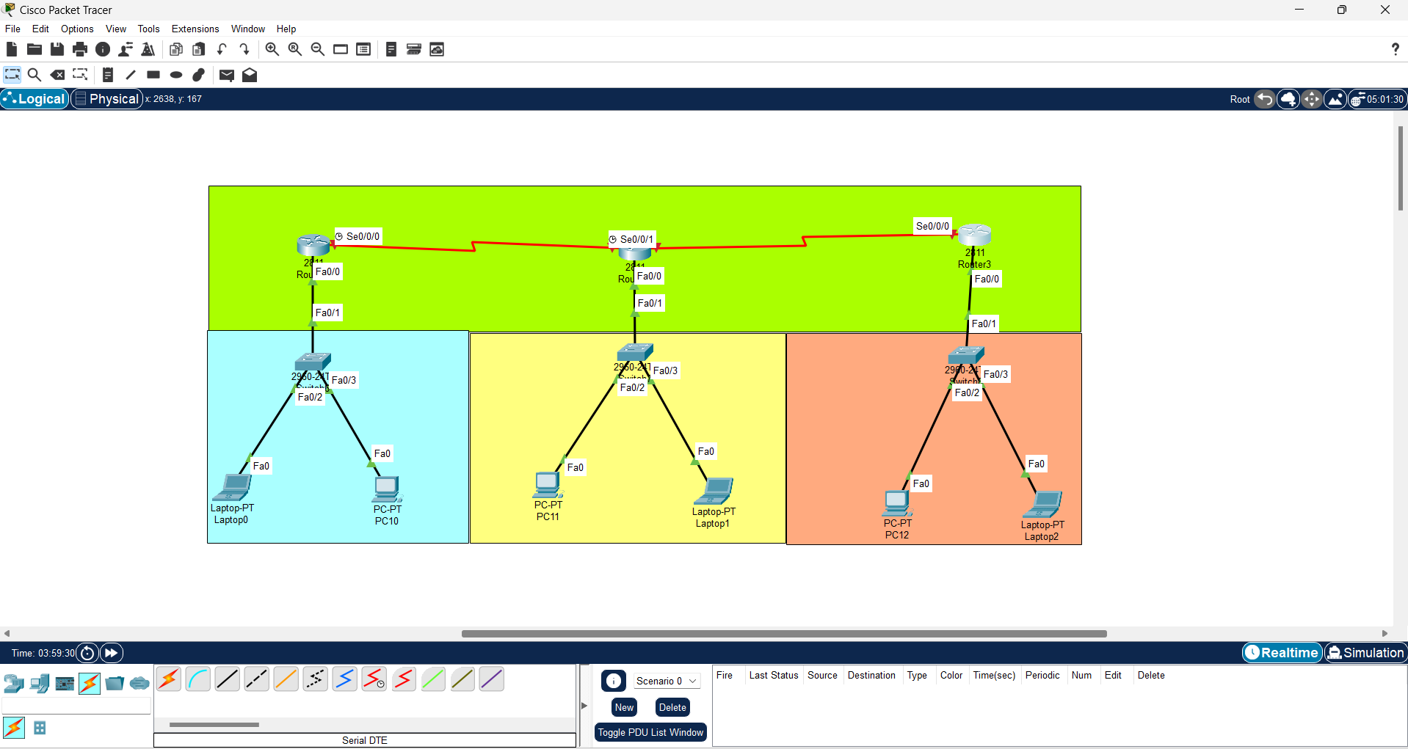
Figure 10.1 Selecting devices

Step2: Assigning IP addresses to the devices. Here we are subnetting with subnet mask /25.
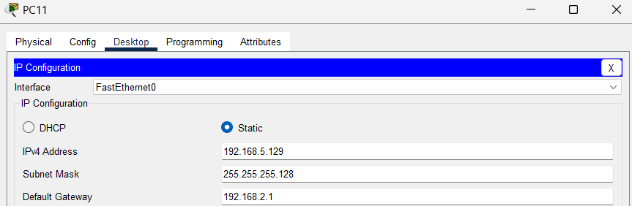
Figure 10.2 Assigning Subnet IP Address
Step3: Ping the devices to check the connectivity.
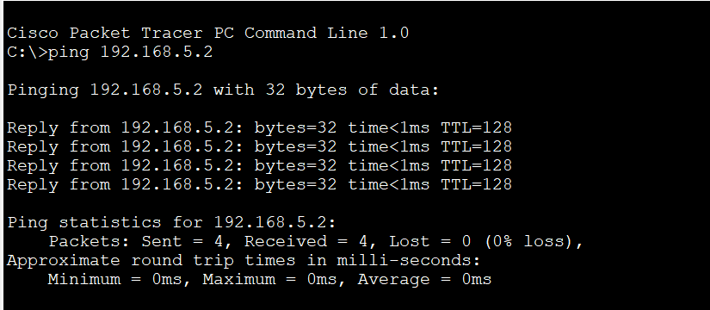
Figure 10.3 Ping of devices

EXPERIMENT: 11
AIM: Practical implementation of basic network command and Network configuration commands like ping, ipconfig, netstat, tracert etc. for troubleshooting network related problems.
Apparatus (Software): Cisco packet tracer.
Description: What is a Networking Command?
Networking commands are tools used in command line interfaces to execute various
network tasks. They allow users to diagnose network problems, modify network settings,
transfer files, and establish distant connections. These commands provide essential
functionality for network administrators and troubleshooters, allowing for efficient network
control and troubleshooting
Networking commands are tools used in command line interfaces to execute various network tasks. They allow users to diagnose network problems, modify network settings, transfer files, and establish distant connections. These commands provide essential functionality for network administrators and troubleshooters, allowing for efficient network control and troubleshooting.
Procedure: Various Basic Networking Commands
Many system commands can be used to know about the network connection parameters. You can use these networking commands on the network. Here we will be learning about a few of these commands. We will discuss what the commands do and what information they can give you about the system. So let's hop on as we learn about the various basic networking commands.
Ping: It is one of the basic networking commands to test the connection between the local machine and the host server. This command sends a small amount of data to the host server, and in return, the host server sends a reply to the computer. Information like the IP address of the host server, the amount of data sent, time to live, and time needed for sending and receiving the data are recorded and displayed to the user.
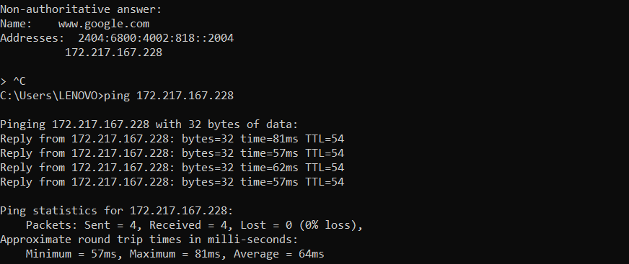
Figure 11.1 ping
Ipconfig: As the command name suggests, it gives information about the IP address. It not only gives the IP address of the computer it is executed on but also much more information as DNS addresses are stored in the cache. It has options to show even the computer's MAC address, renew the IP address, release the current IP address, flush the DNS cache, and help.
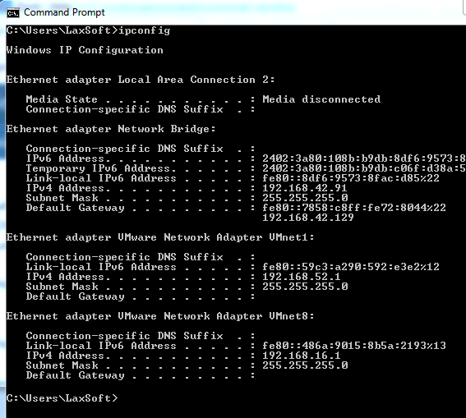
Figure 11.2 ipconfig
Netstat: This command displays the connections active on the computer and the ports the computer is listening to. The command displays the four parameters: proto, local address, foreign address, and state. The proto column shows the type of connection, and the local address shows the IP address and the port number of the connection local machine. The proto column also indicates the foreign address, specifies the IP address and port number of the connection in the host server, and the state shows whether the connection is established or not.
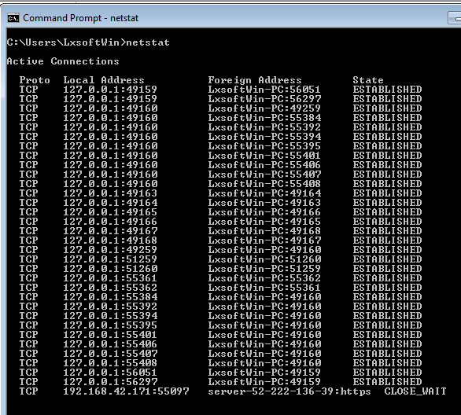
Figure 11.3 netstat
Tracert: The tracert command traces the route from a computer to a host server. It traces the connection for a fixed maximum number of hops. It is one of the basic networking commands. It is used to diagnose path-related problems. The information it displays about the connection route includes the IP addresses for each intermediate server and 3 round trips for each server. You can set various options for this command, like whether to resolve names of intermediate server IP addresses, the maximum number of hops in the path, and the maximum amount of time to wait for a reply.
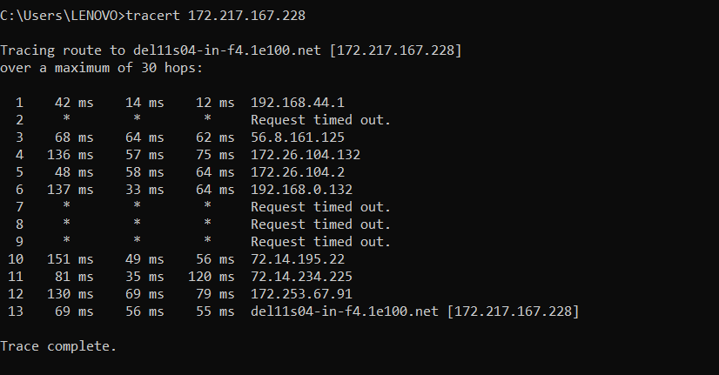
Figure 11.4 tracert
Arp: The arp command is a short form for Address Resolution Protocol. This command is used to display and modify the IP to the physical address translation table used by the address resolution protocol. It has many options, of which a few are to display current ARP entries, specify an internet address, delete a host in the ARP table, specify a physical address, and many more.
•arp -a: This command is used to display the ARP table for a particular IP address. It
also shows all the entries of the ARP cache or table.
•arp -g: This command works the same as the arp -a command.
•arp -d: This command is used when you want to delete an entry from the ARP table
for a particular interface. To delete an entry, write arp -d command along with the IP
address in a command prompt you want to delete
arp -a:This command is used to display the ARP table for a particular IP address. It also shows all the entries of the ARP cache or table.
arp -g: This command works the same as the arp -a command.
arp -d: This command is used when you want to delete an entry from the ARP table for a particular interface. To delete an entry, write arp -d command along with the IP address in a command prompt you want to delete
arp -d: You can also delete all the entries from the ARP table. This command will remove or flush all the entries from the table.
arp -s: This command is used to add the static entry in the ARP table, which resolves the InetAddr (IP address) to the EtherAddr (physical address). To add a static entry in an ARP table, write arp -s command along with the IP address and MAC address of the device in a command prompt

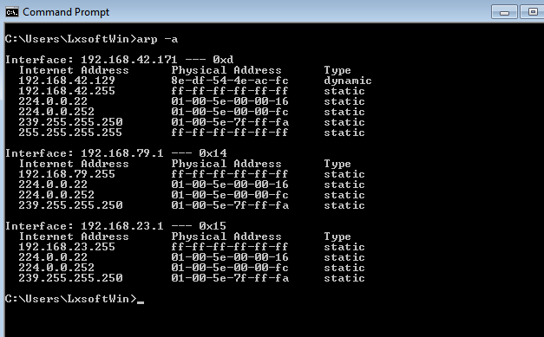
Figure 11.5 arp
NsLookup: The NsLookup command is a command-line utility. It is used in networking to query the Domain Name System (DNS). Then it obtains information about domain names, IP addresses, and other DNS-related data. When you run the NsLookup command followed by a domain name or IP address, it will display the corresponding DNS records associated with that domain or IP. This command is commonly used to troubleshoot DNS-related issues, check DNS resolution, and gather information about domain configurations.
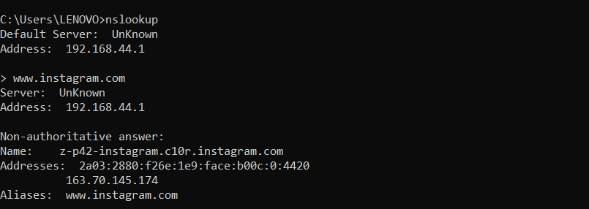
Figure 11.6 nslookup

Select the router icon, then select the 1841 router model. Place the router
anywhere on the network.
Select the router icon, then select the 1841 router model. Place the router
anywhere on the network.
Select the router icon, then select the 1841 router model. Place the router
anywhere on the network.
Select the router icon, then select the 1841 router model. Place the router
anywhere on the network.
Select the router icon, then select the 1841 router model. Place the router
anywhere on the network.
Select the router icon, then select the 1841 router model. Place the router
anywhere on the network.
Select the router icon, then select the 1841 router model. Place the router
anywhere on the network.
Select the router icon, then select the 1841 router model. Place the router
anywhere on the network.
Select the router icon, then select the 1841 router model. Place the router
anywhere on the network.
Select the router icon, then select the 1841 router model. Place the router
anywhere on the network.
Select the router icon, then select the 1841 router model. Place the router
anywhere on the network.

EXPERIMENT: 12
AIM: Configuration of networks using static and default routes.
Apparatus (Software): Cisco packet tracer.
Description: What is Routes?
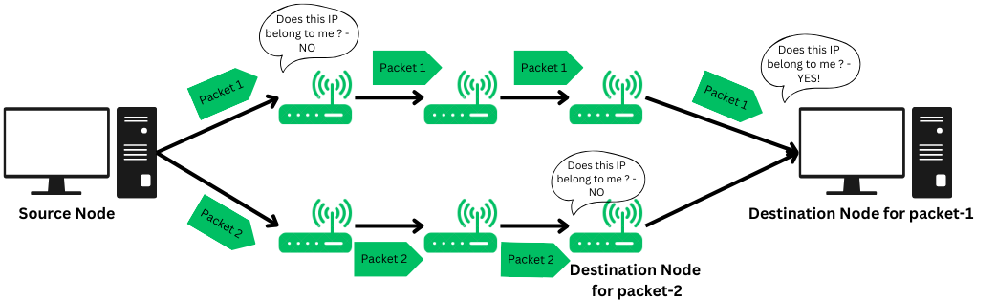
Figure 12.1 Routing
Routes is the process of determining paths through a network for sending data packets. Routes ensures that data moves effectively from source to destination, making the best use of network resources and ensuring consistent communication. Routes also known as Routing. It is a process that is performed by layer 3 (or network layer) devices to deliver the packet by choosing an optimal path from one network to another. It is an autonomous process handled by the network devices to direct a data packet to its intended destination. The node here refers to a network device called – ‘Router‘. Routing is a crucial mechanism that transmits data from one location to another across a network (Network type could be any like LAN, WAN, or MAN). The process of routing involves making various routing decisions to ensure reliable & efficient delivery of the data packet by finding the shortest path using various routing metrics.

Static Routing: Static routing is also called as “non-adaptive routing”. In this, routing configuration is done manually by the network administrator. Let’s say for example, we have 5 different routes to transmit data from one node to another, so the network administrator will have to manually enter the routing information by assessing all the routes.

Default Routing: This is the method where the router is configured to send all packets toward a single router (next hop). It doesn’t matter to which network the packet belongs, it is forwarded out to the router which is configured for default routing. It is generally used with stub routers. A stub router is a router that has only one route to reach all other networks.

Dynamic Routing: Dynamic routing makes automatic adjustments of the routes according to the current state of the route in the routing table. Dynamic routing uses protocols to discover network destinations and the routes to reach them. RIP and OSPF are the best examples of dynamic routing protocols. Automatic adjustments will be made to reach the network destination if one route goes down.

Procedure: Implementation of Static Routing:
To implement a static routing, So, we will Create a network where we will perform the static routing.
Step1: Setup a Network for configuring a static network.
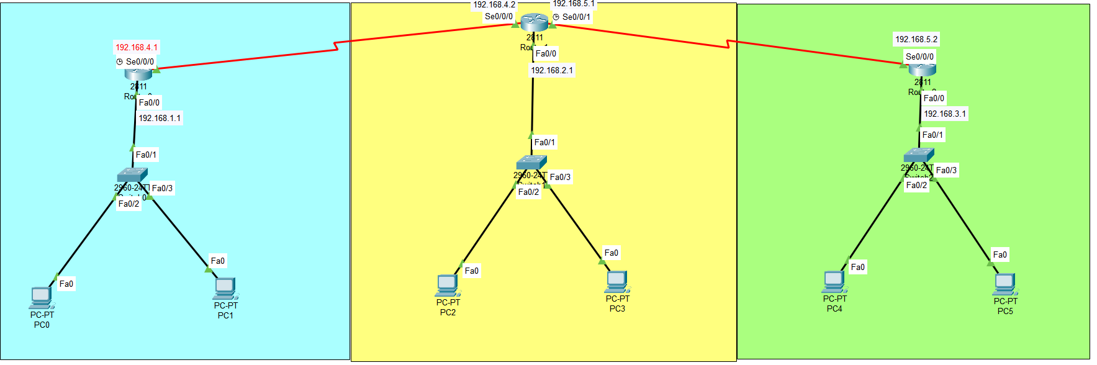
Figure 12.2 Network
Step2: Give IP addresses to Pc’s and Give the default gateway.
Step3: Then providing the IP addresses to the router interfaces.
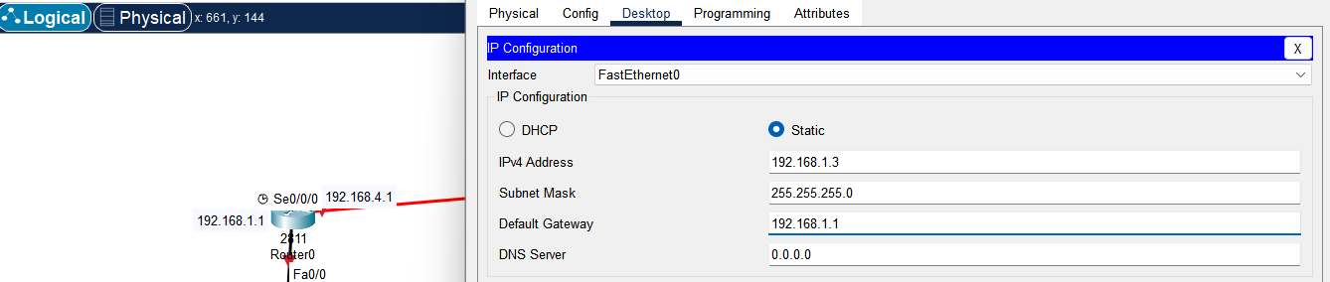
Figure 12.3 Assigning IP
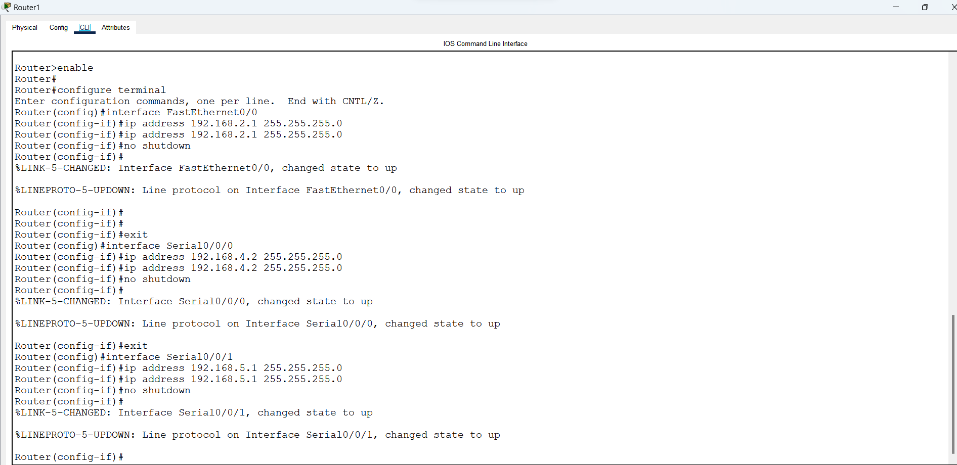
Figure 12.4 Configuring interface
Step4: Checking the network by sending packets within the same network.
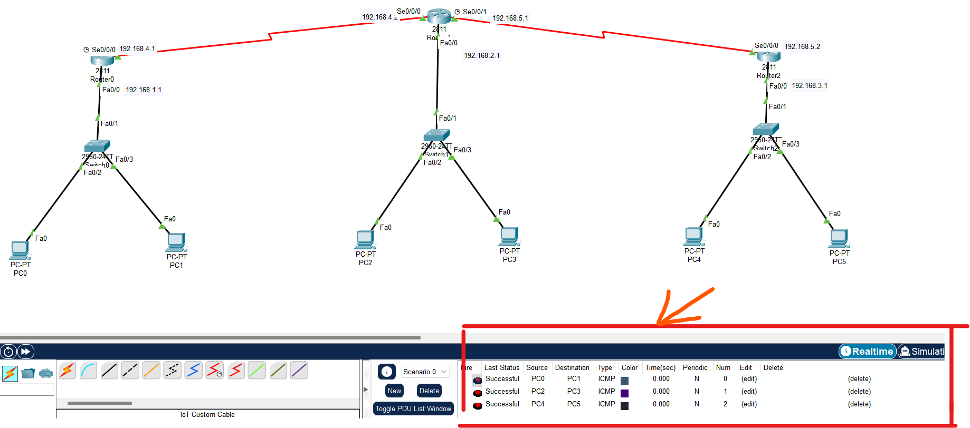
Figure 12.5 Packet Status
Step5: Now configuring a static routing. (e.g. Static routing for router0)
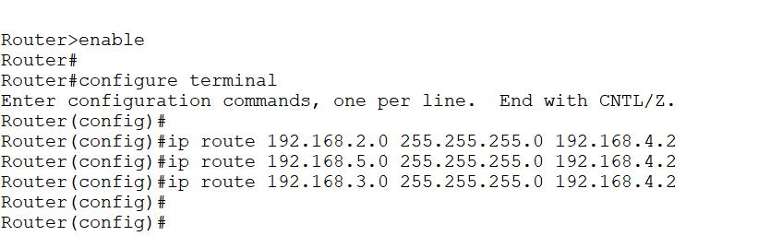
Figure 12.6 Configuring static routing
Step6: Now sending packets to different network after configuring a static routing.
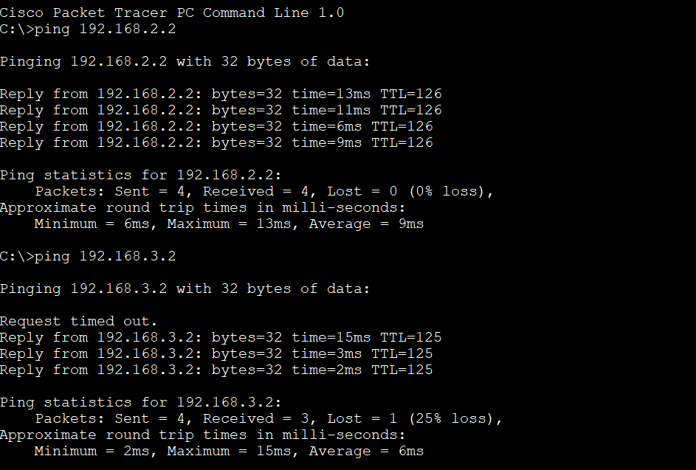
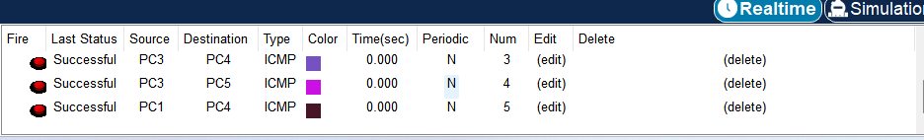
Figure 12.7 Packet delivered
Implementation of Default Routing:
To implement a default routing, So, we will Create a network where we will perform the default routing.
Step1: Setup a Network for configuring a static network.
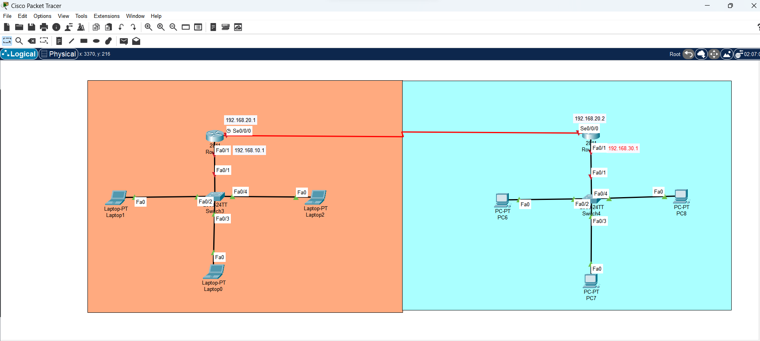
Figure 12.8 Network
Step2: Give IP addresses to Pc’s and Give the default gateway.
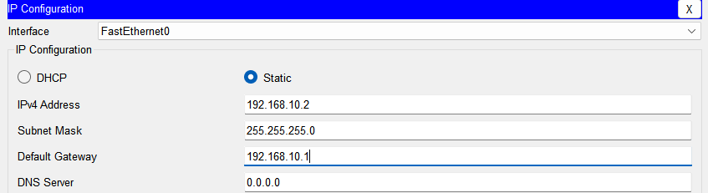
Figure 12.9 Assigning IP
Step3: Then providing the IP addresses to the router interfaces.
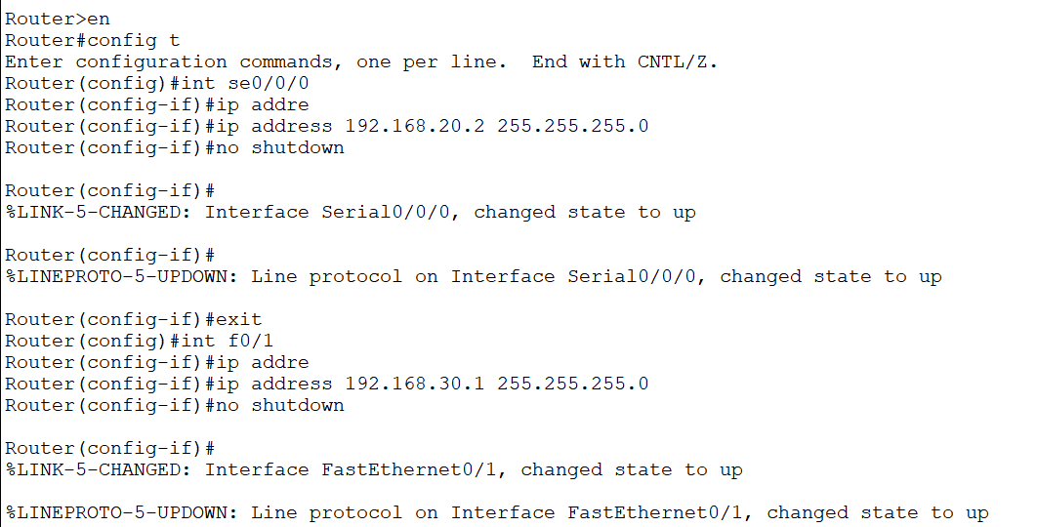
Figure 12.9 Configuring interface

Step4: Checking the network by sending packets within the same network.
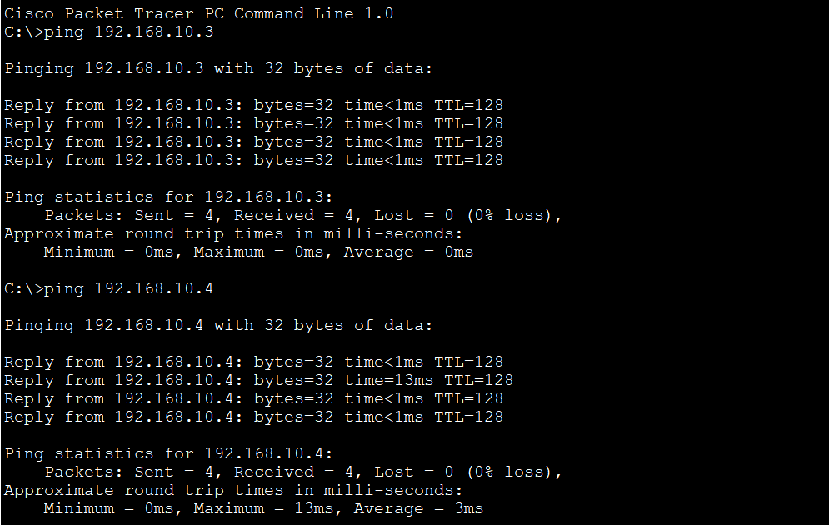
Figure 12.10 Packet status
Step5: Now configuring a default routing. (e.g. Default routing for router0)
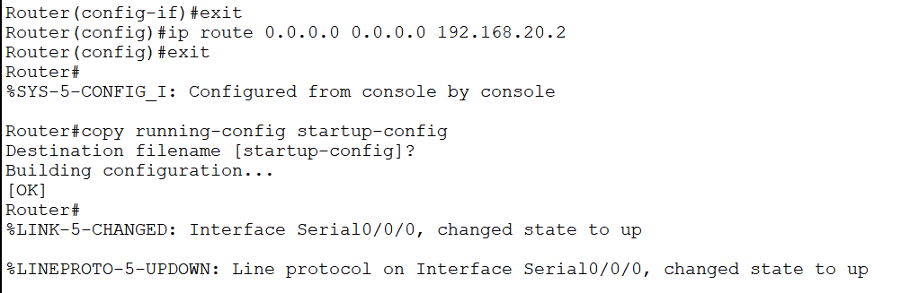
Figure 12.11 Configuring default routing
Step6: Now sending packets to different network after configuring a default routing.
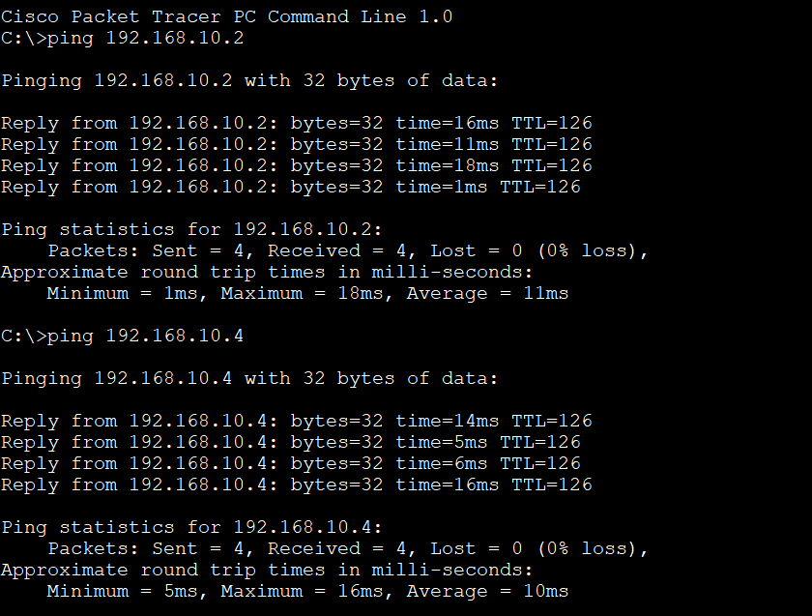
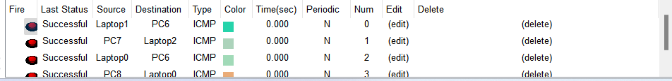
Figure 12.12 Packet delivered
Select the router icon, then select the 1841 router model. Place the router
anywhere on the network.
Select the router icon, then select the 1841 router model. Place the router
anywhere on the network.
elect the router icon, then select the 1841 router model. Place the router
anywhere on the network.
elect the router icon, then select the 1841 router model. Place the router
anywhere on the network.
Select the router icon, then select the 1841 router model. Place the router
anywhere on the network.
Select the router icon, then select the 1841 router model. Place the router
anywhere o

